

|  |  |  |
| --- | --- | --- |
| **Module** | **Portfolio** | **Assessment Type** |
|  |  |  |
| Collaborative Development (5CS024) | 1 | Individual Report |
|  |  |  |

[Project Case - Role]

Student Id : 2329256

Student Name : Mahesh Pun

Section : L5CG13

Group : L5CG13 Group-D

Role : Developer

Instructor : Anmol Adhikari

Submitted on : 02-04-2023

Word Count : 5520

# Acknowledgement

Thank you for submitting the report. Your analysis and recommendations have provided valuable insights into the progress and status of our development efforts. Your attention to detail and thoroughness in presenting the information is greatly appreciated. We will carefully consider your findings and use them to make improvements to our development process. Your contribution is essential to the success of our project, and we look forward to continuing to work with you.

# Self-appraisal form

|  |  |  |  |
| --- | --- | --- | --- |
| Student number | 2329256 | Name | Sanjeev Kumar Sah |
| Project | Resturant Dine-in Reservation System | Date |  |
| Role | Developer | Team | L5CG3 (Group B) |
| Sprint (1 or 2) | Sprint 1 |  |  |

# Personal objectives – performance measurement

|  |  |  |  |  |
| --- | --- | --- | --- | --- |
| **Objectives** | **Evidence provided.** | **Evaluation**  Student / tutor | | |
| Choosing for the relevant technologies | There are many tools and techniques that can be used for web development. It is important to choose the technology that is most suited for our project. I have done some extensive research in different languages and frameworks to choose the relevant technologies. I have also researched on different database system. The main objective is to choose the technology that is suited and that meets the end goal. Link to Appendix A | 9 | |  |
|  |
| Tutor feedback: |  | | | |
| Implementing functional requirement | The main objective of our project is to meet all the requirement for users using relevant technologies. We need to make sure that we analyse all the given requirements and work accordingly. To implement the requirement we need to design, develop, and test out work based on the all the requirements and features needed in our application. We must be effective and efficient to make sure we achieve our objective.  Link to Appendix B | 9 |  |  |
|  |
| Tutor feedback: |  |  |  |  |
|  |  |  | /20 | /20 |

# Collaboration Document

Good communication is important for a scrum team to function properly. I have used various platforms to communicate with our team members. I have used Jira as our official communication platform. With that we have also used google space to make it easy to share file and talk with team members. For our unofficial communication I have used physical meeting. I have also participated in daily scrum and team meeting for good communication. Link to Appendix C

# Continuing Personal Development (CPD)

To meet the user objective, I need to enhance my knowledge and expertise accordingly the requirement. I have used different platforms such as Google, Youtube and Chat-GPT. I also have used mobile app such as Cursa to gain more knowledge. For crash course and beginner courses I used Youtube. For problem solving and debugging I have used Google and Chat-GPT. I have also used documentation such as Django documentation for more information.

Link to Appendix D

# Issue tracking

Issue tracking is important to meet the user requirement in effective way. To make sure my work has no issue at first, I have identified the issue given by product owner. I have used different platform such as stack overflow to understand what is causing the problem. After identification I have used tools, such as google and stack overflow to debug my code and solve the issue. I have used React documentation as well.

Link to Appendix E

# Appendix A

## 1.Choosing for relevant technologies

**1.1Programming languages**

### JavaScript

JavaScript is a scripting or programming language. It was invented by Brendan Eich. It was released in 1995. JavaScript is an open-source programming language and used for creating dynamic and interactive content on websites and used across various platforms. It allows you to implement complex features on web pages. Additionally, many popular JavaScript libraries and frameworks, such as React, Vue.js, and Angular, are also open source, allowing developers to contribute to their development and use them freely in their projects.

**1.1.1.1. Risk of JavaScript.**

* **Cross-Site Scripting (XSS):** XSS involves injecting malicious scripts into web pages viewed by other users, potentially leading to data theft or manipulation.
* **Cross-Site Request Forgery (CSRF):** CSRF exploits a user's authenticated session to perform unauthorized actions on a different website, often leading to fraudulent activities.

**1.1.1.2. Limitation of JavaScript.**

* **Client-Side Security Risk:** It's execution on the client-side makes its code accessible and modifiable by users.
* **Single Inheritance:** As, it follows a prototype-based inheritance model instead of classical inheritance which provides flexibility to language.

* **Issues with Debugging:** In complex web application debugging javascript code can be challenging due to lack of strong typing and the asynchronous nature of javascript.
* **Time-Consuming:** JavaScript based web applications requiring time-consuming downloads of scripts, particularly for large applications.

### 1.1.2. Java

Java is object-oriented language that is free to use and open source. It was founded by James Gosling at Sun Microsystems, Inc. It is a language that requires high level skill and it’s based on C and C++. To use it we need Java Development Kit (JDK) then it is compiled into Java bytecode using Java Virtual Machine (JVM). After that it can be run in any other devices. Its slogan is “write once, run anywhere”.

### 1.1.2.1Risk of Java

* **Performance Risk:** Java has performance issue in low level system.
* **Learning Curve:** Java can be hard to learn and require good knowledge.
* **Security Issue:** There is security issue as hacker can gain unauthorized access.

### 1.1.2.2Limitation of Java

* **Limited Language Features:** There is limited feature in terms of syntax and language.
* **Platform dependency:** Java programs may on run on other platforms or OS.
* **Memory Limitation:** Java has garbage collector which can cause memory performance issue.

### 1.2 Frameworks

**1.2.1** Express.js

Express.js is an open-source and freely available web development framework. It was developed by TJ Holowaychuk in 2010. It supports JavaScript programming language for server-side development. It follows a minimalist architecture and middleware-based architecture pattern. One of its main features is it is faster server-side development and provides broad features for building web and mobile applications.

#### 2.1.1 Risk of Express.js

* **Lack of in-built features:** Due to lack of advanced features developers may need to depend on additional middleware or libraries to implement specific functionalities that are not included.
* **Security vulnerabilities:** Like other software, Express.js is susceptible to security vulnerabilities that attackers may exploit. Therefore, developers must stay updated on security provided by the Express.js community to mitigate these risks.
* **Frequent updates:** Express.js is an open source which receives regular updates for new features and security improvements, but mishandling updates may also cause compatibility issues.

## 1.2.1.2Limitation of Express.js

**Structural disorganization:** Due to lack of structural organization risks of code becoming non-understandable.

**Callback issues:** The risk of encountering numerous issues with callbacks, complicating asynchronous code flow and maintenance.

**Complex error messages:** The risk of facing challenging-to-understand error messages, potentially hindering effective debugging and troubleshooting efforts.

**1.2.1** React.js

React is a front-end JavaScript framework which is used for building user interfaces-based UI components. It was developed by Facebook Software Engineer, Jordan Walke, and used for the first time in 2011 for Facebook's Newsfeed feature. React creates a VIRTUAL DOM in memory. React can be used to create simple to complex web applications and it also enables developers to create reusable components (Meta Platforms, Inc, 2024).

#### 1.2.1.1 Risk of React.js

* **Insecure Data Storage:** Improper handling of sensitive data within React.js applications, can lead to data breaches or unauthorized access.
* **Scalability Issue:** It can require additional resources depending in scale of application.
* **Security Issue:** It need to be up to date with security updates to minimize risk.

## 1.2.1.2Limitation of React.js

* **Lack of Proper Documentation:** It leads to sparse guides and incomplete instruction.
* **Development Speed:** It leads discomfort to developers with frequent learning.

**JSX Complexity:** JSX can cause confusion and complicate the learning curve for developers due to its mix of HTML and JavaScript.

### 1.2.2. Flask

Flask is a written in python. It is lightweight framework used for web development. It was developed by Armin Ronacher of Pocoo in 2010. It is used to develop small to medium-sized web applications. It is also used to develop APIs. It is Web Server Gateway Interface (WSGI) based framework. It also uses jinja2 template engine. (Python, 2023)

## 1.2.2.1Risk of flask

* **Security Issue**: There is no built-in security features in flask.
* **Debugging:** As, flask is dynamic in nature, debugging can be difficult in flask.
* **Issue of Scalability:** It is not suitable and design for large scale application.

### 1.2.2.2. Limitation of flask

* **Dependency Management:** Flask uses third-party library so there is dependency issue.
* **Steep Learning Curve:** To work on flask, it requires good python knowledge.
* **Limited Functionality:** There is not much bult-in features in flask.

#### 1.3 Database

##### 1.3.1. MySQL

MySQL is an open-source database management system. It is one of the most popular DBSM. It is based on rational databases management system (RDBMS). It is developed and support by Oracle Corporation. It helps user organized its database. It is based on rational database, so it lets user store data in different tables rather than putting all data in a single big storeroom.

### 1.3.1.1. Risk of MySQL

* **Security Issue**: As, it is connected to internet there is security risk.
* **Limited Scalability**: There is limit for the amount of data it can hold.
* **Performance Issue**: When there is large data, there is performance struggle.

### 1.3.1.2. Limitation of MySQL

* **Compatibility Issue**: It is not well compatible with other database system.
* **No support of JSON**: It does not natively support JSON data.
* **No support of NoSQL**: It does not natively support NoSQL.

#### 1.3.2 SQlite

SQlite is a light weight and easy-to-use database management system that is based on rational database management system (RDBMS). It was designed by Richard Hipp. It a serverless database engine that has zero-configuration. It is mostly used in embedded system. It provides small and simple choice for developers.

### 1.3.2.1 Risk of SQite

* **Security risk:** SQlite is based on file-based system so it is less secure.
* **No built-in network support:** There is lack of built-in network support.
* **No built-in authentication:** There is lack of good built-in authentication.

### 1.3.2.2 Limitation of SQlite

* **Limited Scalability**: It is not designed to handle large amount of data.
* **Limited Support for concurrency**: It cannot handle multiple write operations.
* **Data Corruption**: Being a file-based system, there is high chance of data corruption.

**1.Justification for choosing relevant technologies.**

* 1. **Why did I choose JavaScript.**

|  |  |
| --- | --- |
| **No.** | **Justification** |
| 1 | JavaScript provides a simple and easy-to-use syntax. |
| 2 | It offers a wide range of visualization options. |
| 3 | JavaScript benefits from a large and supportive community. |
| 4 | It boasts a rich standard library and built-in functions. |

* 1. **Why did I choose React.js.**

|  |  |
| --- | --- |
| No. | Justification |
| 1 | React.js provides built-in security features such as CSRF protection. |
| 2 | It seamlessly integrates with various database management systems. |
| 3 | React.js is versatile and suitable for data-driven applications. |
| 4 | It has good community support and comprehensive documentation. |

* 1. **Why did I choose Express.js.**

|  |  |
| --- | --- |
| No. | Justification |
| 1 | Express.js offers efficient routing and built-in security features like CSRF protection. |
| 2 | It seamlessly integrates with various database management systems, enhancing flexibility. |
| 3 | Express.js is versatile, serving as a robust framework for building APIs and web applications. |
| 4 | It has good community support and extensive documentation, easing development challenges. |

* 1. **Why did I choose MySQL.**

|  |  |
| --- | --- |
| No. | Justification |
| 1 | It is cross-platform compatible. |
| 2 | It is easily scalable and reliable to use. |
| 3 | It is easy to use as the query is easily understandable. |
| 4 | It had good built-in security features. |

**2.Justification for not choosing relevant technologies.**

* 1. **Why I did not choose Java.**

|  |  |
| --- | --- |
| No. | Justification |
| 1 | It is relatively complex language. |
| 2 | It is heavy as it takes much more memory |
| 3 | It has more development time because of memory usage. |
| 4 | It is costly to run in shared hosting site. |

* 1. **Why I did not choose Flask.**

|  |  |
| --- | --- |
| No. | Justification |
| 1 | It has limited features as it is a micro-framework. |
| 2 | It is not scalable as it only supports medium-sized applications. |
| 3 | It has no build-in Object Relation Mapping (ORM). |
| 4 | There is no security system such as CSRF protection. |

* 1. **Why I did not choose SQlite.**

|  |  |
| --- | --- |
| No. | Justification |
| 1 | It only handles low to medium traffic HTTP request. |
| 2 | It is not scalable as it is mostly restricted to 2GB. |
| 3 | There is lack of advanced database features such as multiple users. |
| 4 | It lacks features such as access control. |

**Appendix B**

# 1.Implementing Functional Requirement

In this project I am working on admin panel for both front-end and back-end development part of the web application. For this I am using JavaScript as my programming language. I am also using Express.js and React.js framework for JavaScript. For database I am using MySQL.

## Code and its explanations

Registration Model

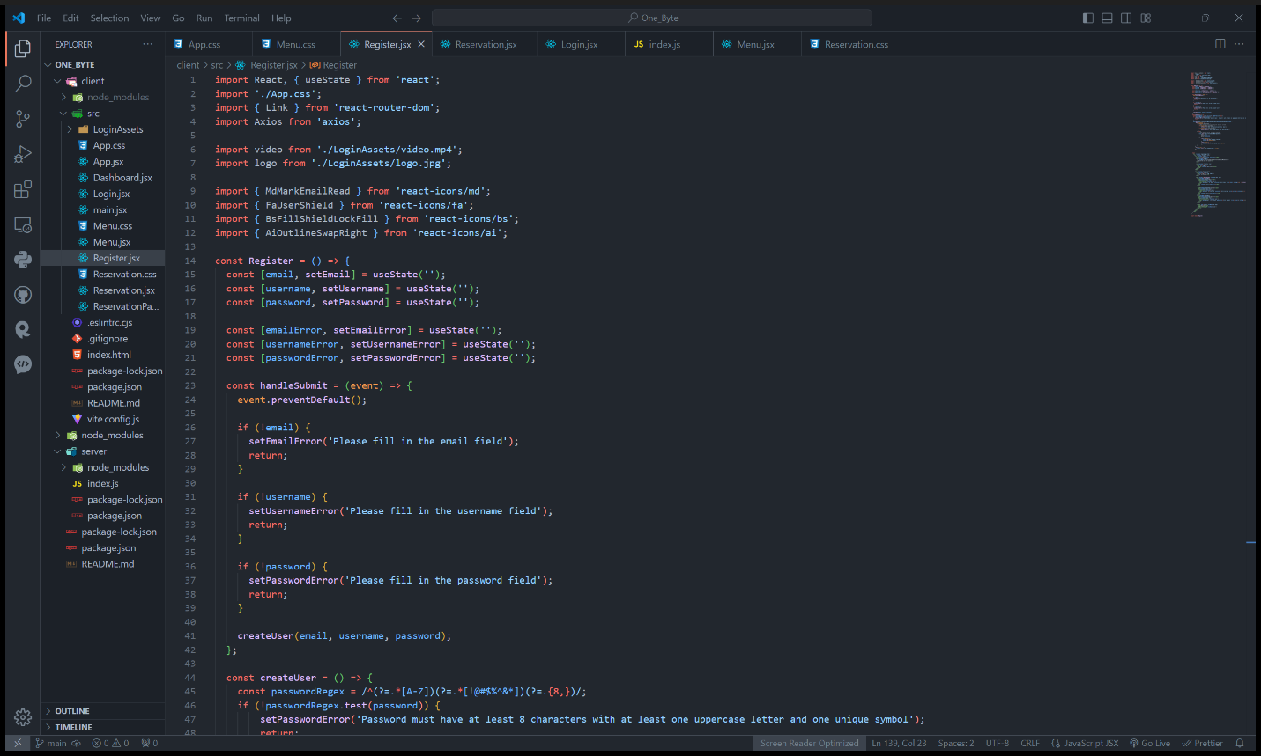

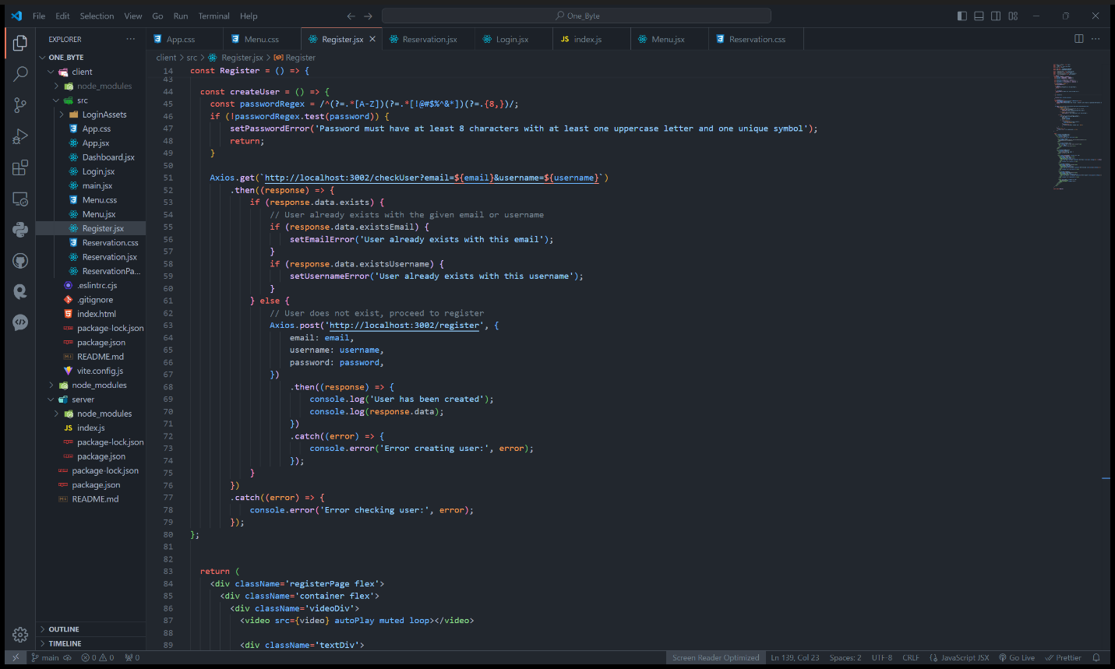

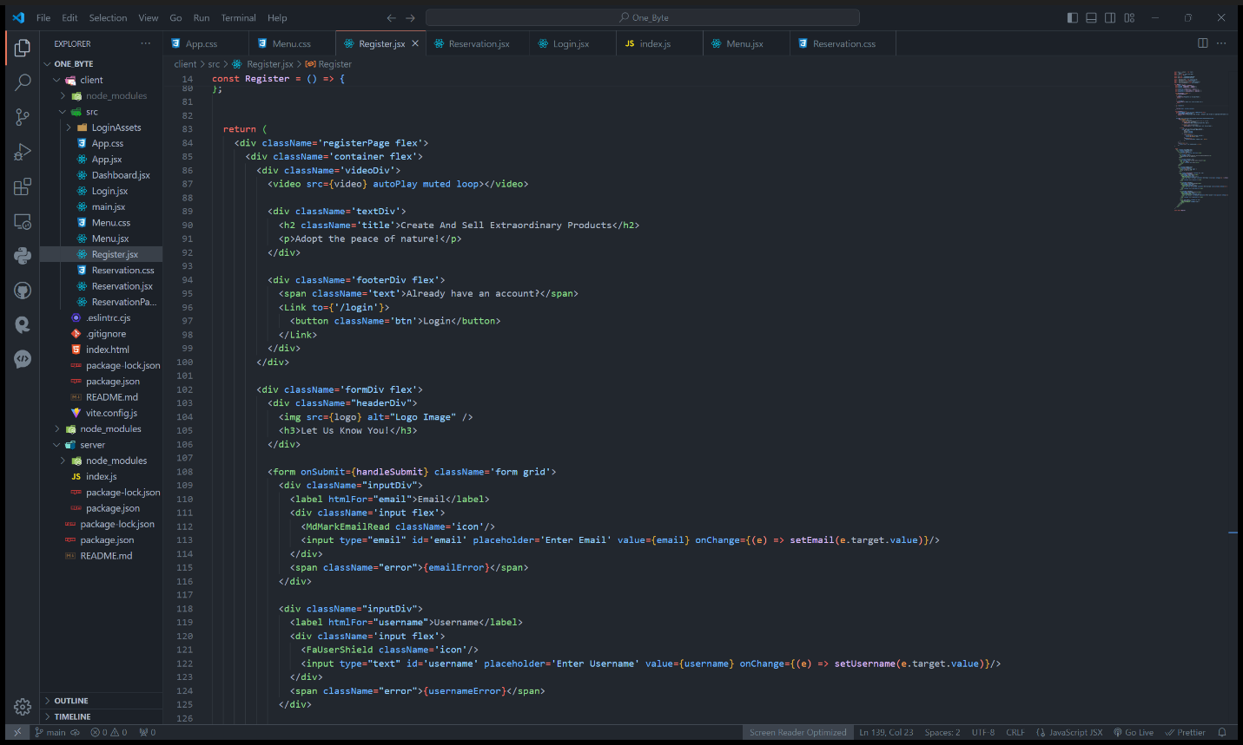

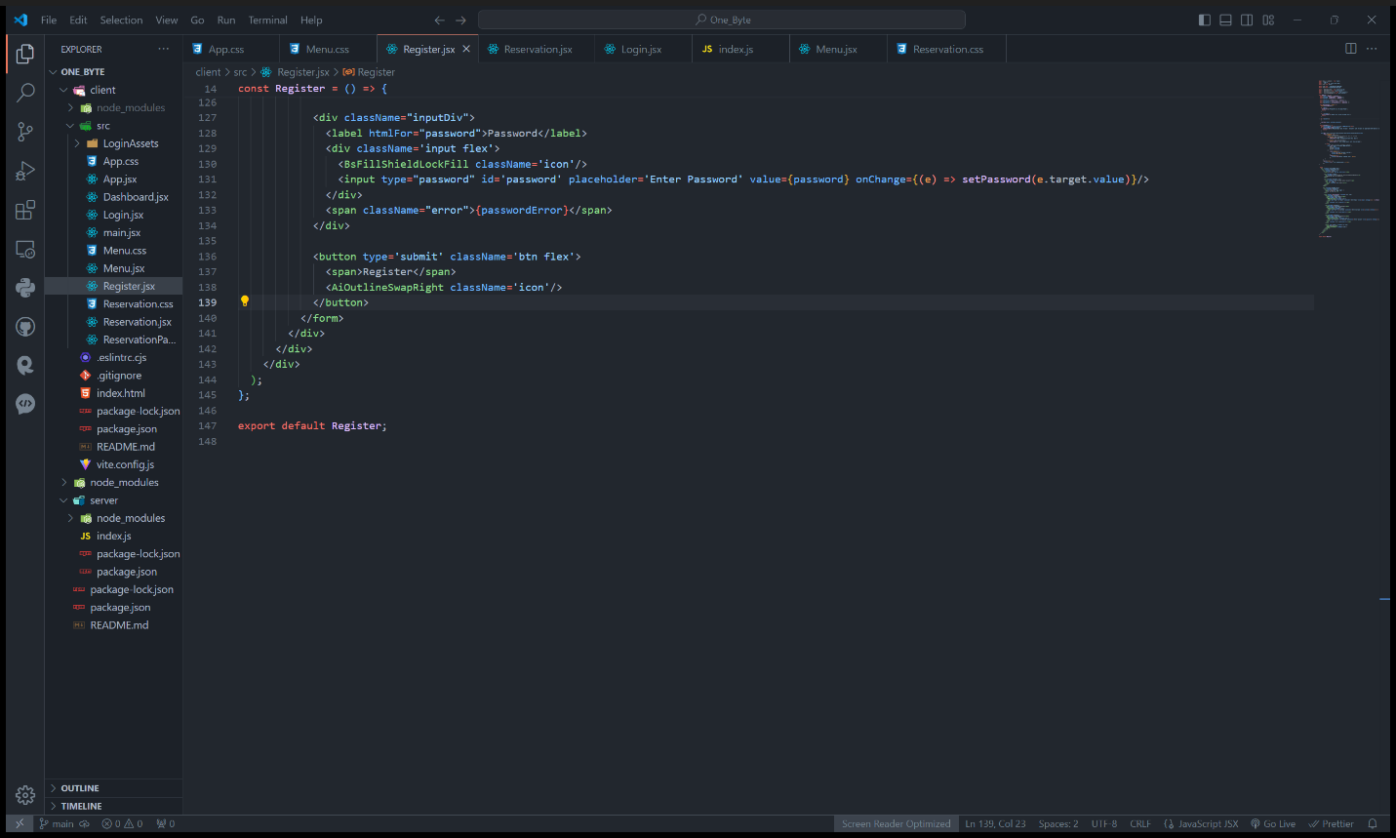

It imports necessary dependencies such as React, Axios for HTTP requests, and icons for visual elements. State variables (email, username, password) are defined using the useState hook to manage form inputs. Error states (emailError, usernameError, passwordError) are defined to handle validation errors. The handleSubmit function is called when the registration form is submitted. It performs client-side validation and sends a request to the backend to create a new user if validation passes. Input fields for email, username, and password are rendered, along with corresponding error messages if validation fails. Upon successful registration, the user is redirected to the login page.

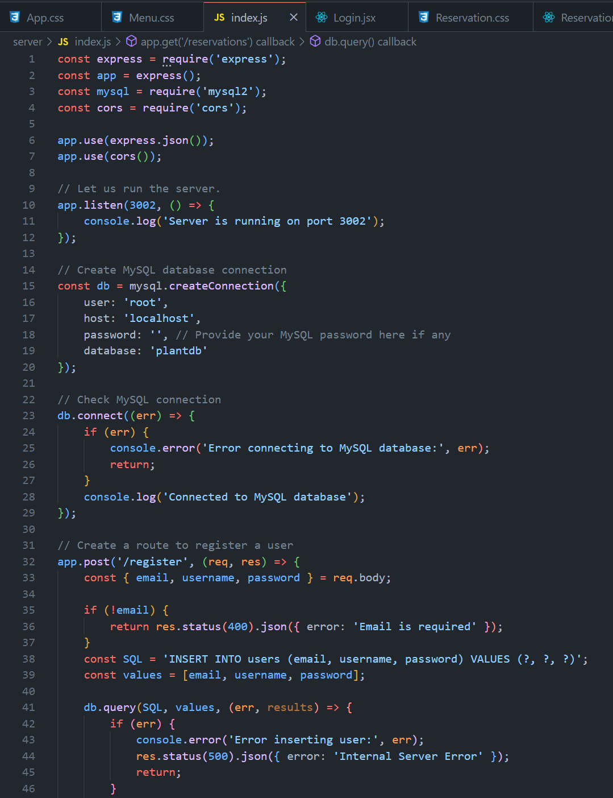

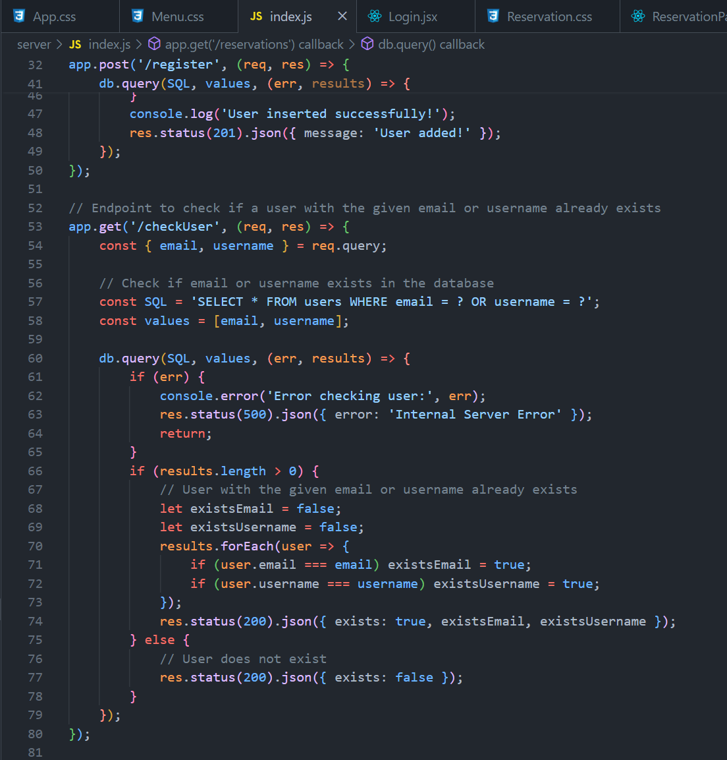

Backend (index.js):

The Express server is set up to handle HTTP requests. A MySQL database connection is established using the mysql2 package. An endpoint (/register) is created to handle POST requests for user registration. When a POST request is received, the server validates the request body to ensure it contains the required fields (email, username, password). If validation passes, the server inserts a new user record into the users table in the database. Before inserting, the server may also check if the provided email or username already exists in the database to prevent duplicate registrations. Upon successful user creation, the server sends a response indicating success. Error handling is implemented to catch any database or server-side errors and return appropriate error responses.

Overall Flow:

When a user fills out the registration form on the frontend and submits it, the form data is sent to the backend via an HTTP POST request. The backend receives the request, validates the data, and creates a new user record in the database if validation passes. If any errors occur during this process, such as validation errors or database errors, appropriate error messages are sent back to the front-end for display to the user. Once the user is successfully registered, they can proceed to log in using the provided credentials.

Registration Database

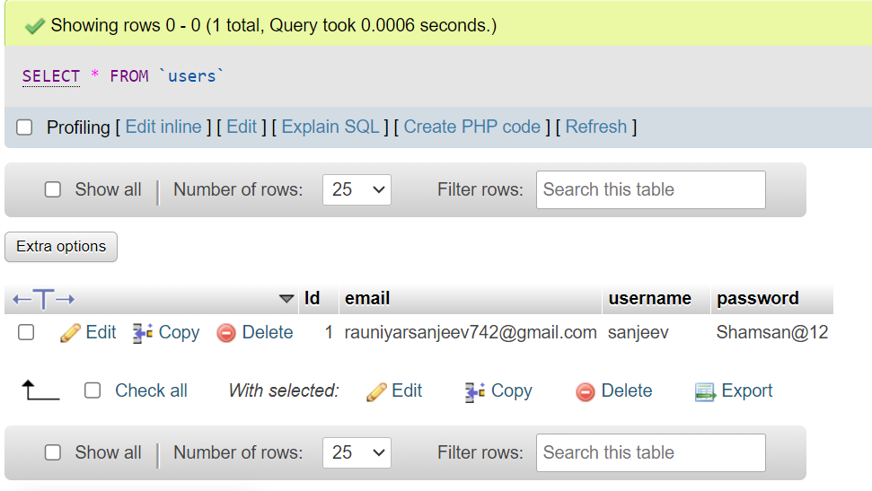

Registration Form



Login Model

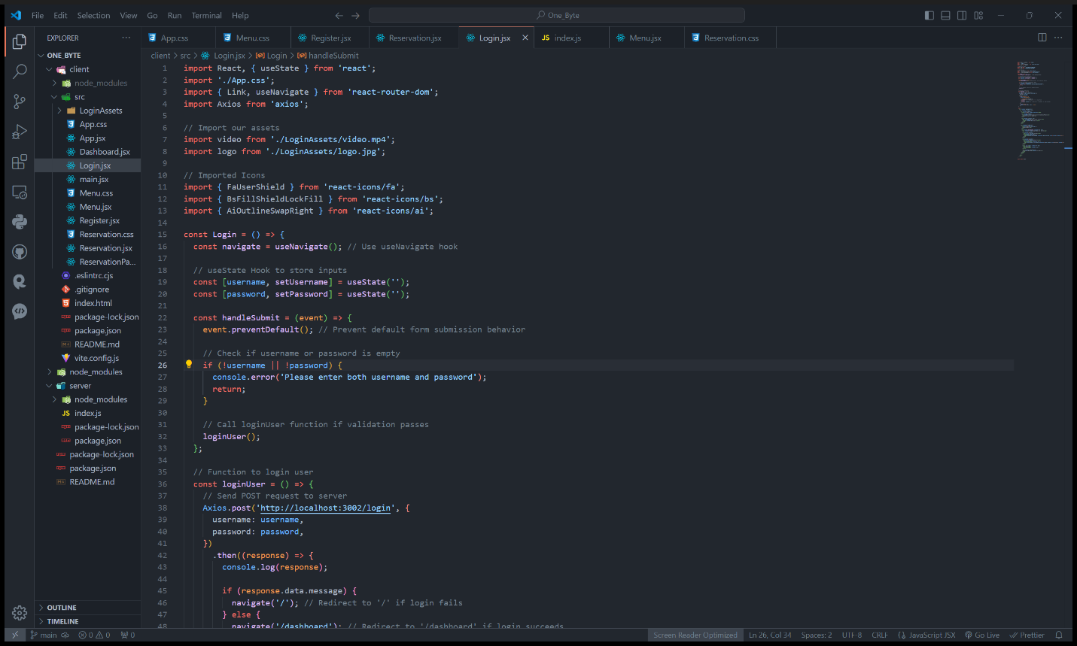

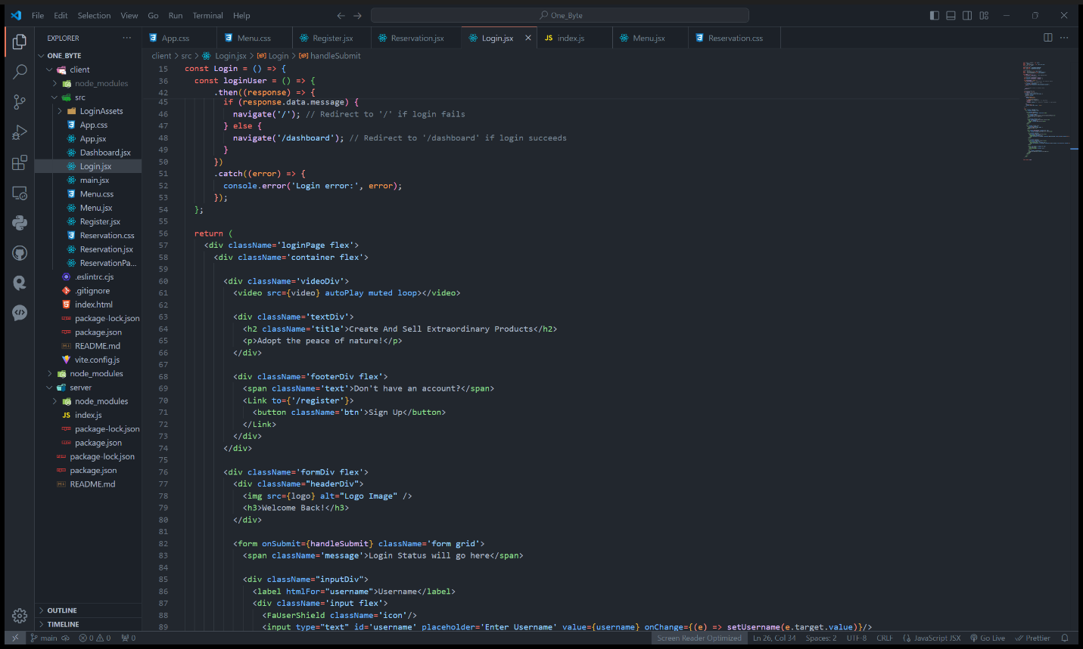

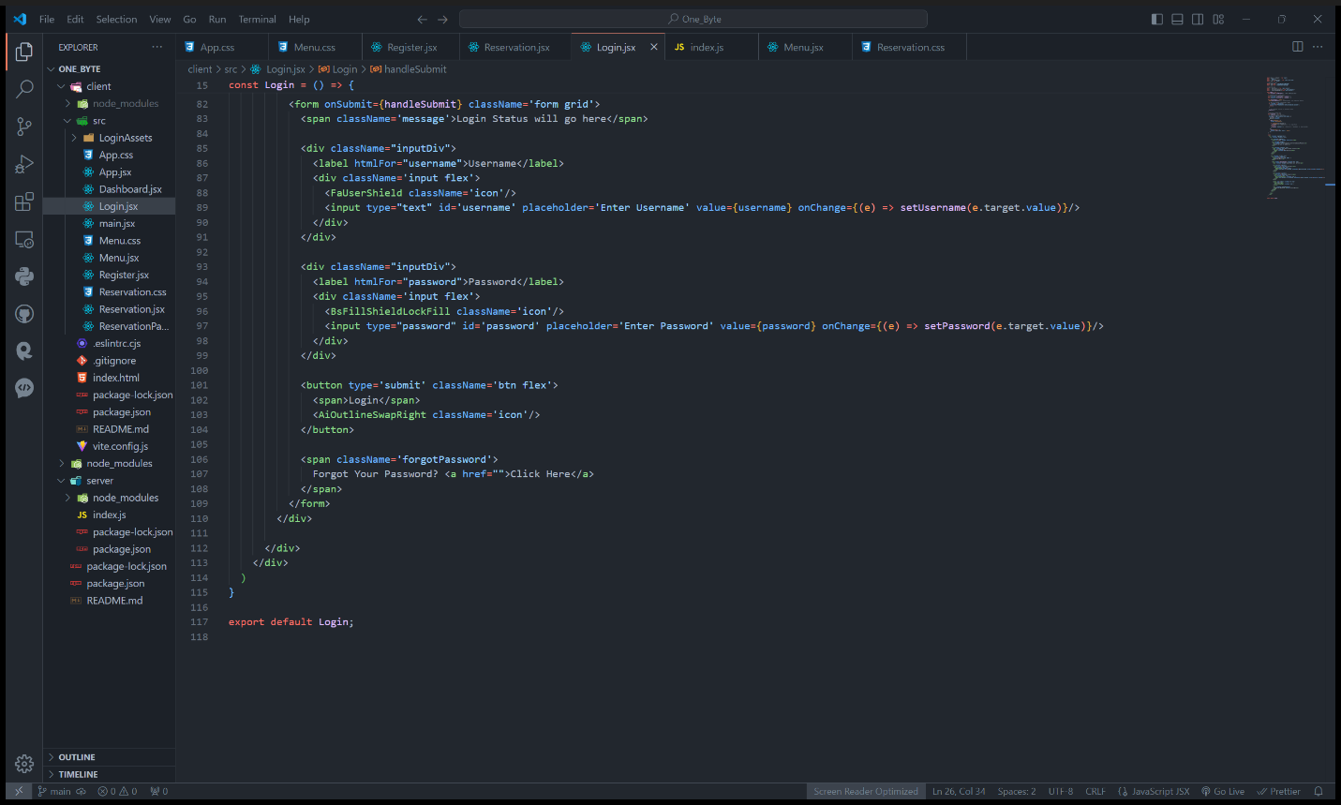

This component contains the UI elements for user login.

It imports necessary dependencies such as React, Axios for HTTP requests, and icons for visual elements.

State variables (username, password) are defined using the useState hook to manage form inputs.

The handleSubmit function is called when the login form is submitted. It performs client-side validation and sends a request to the backend to authenticate the user.

Input fields for username and password are rendered.

Upon successful login, the user is redirected to the dashboard page. If login fails, an error message is displayed.

Additionally, there is a link to the registration page for users who don't have an account yet.

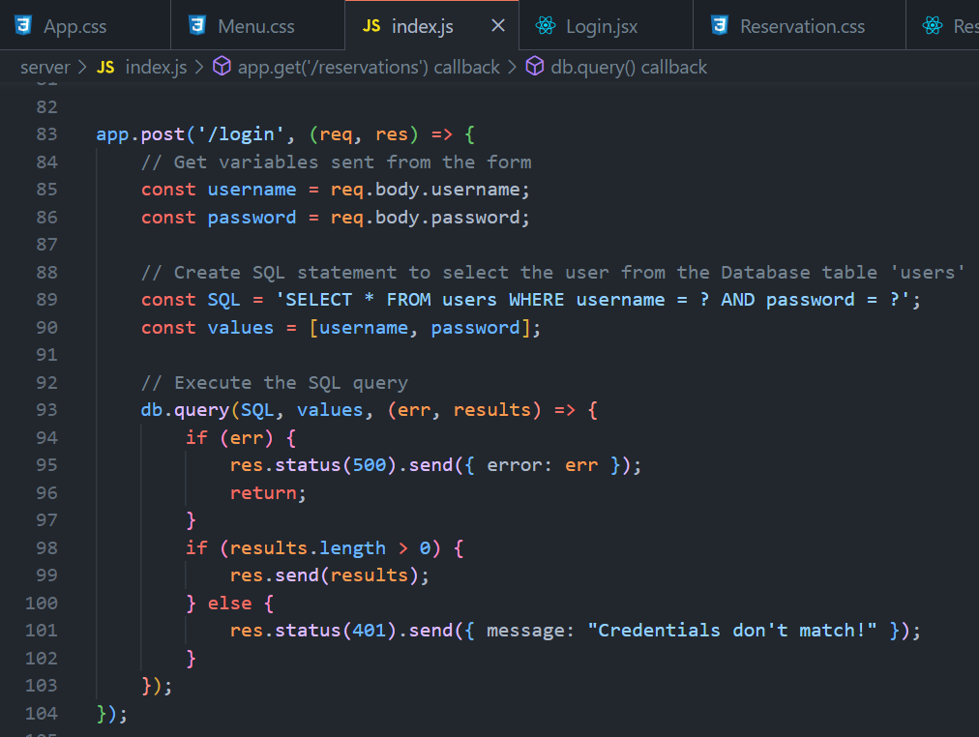

Backend (index.js):

An endpoint (/login) is created to handle POST requests for user authentication. When a POST request is received, the server validates the provided username and password against the records stored in the database. If the credentials match, the server sends a success response with user data. If the credentials don't match, the server sends an error response indicating failed login. Error handling is implemented to catch any database or server-side errors and return appropriate error responses.

Overall Flow:

When a user fills out the login form on the frontend and submits it, the form data is sent to the backend via an HTTP POST request. The backend receives the request, validates the username and password, and checks if they match an existing user's credentials in the database. If the credentials are valid, the user is redirected to the dashboard page. If not, an error message is displayed. This setup ensures secure authentication for users and provides a smooth login experience.

Login Form



Admin Dashboard Code

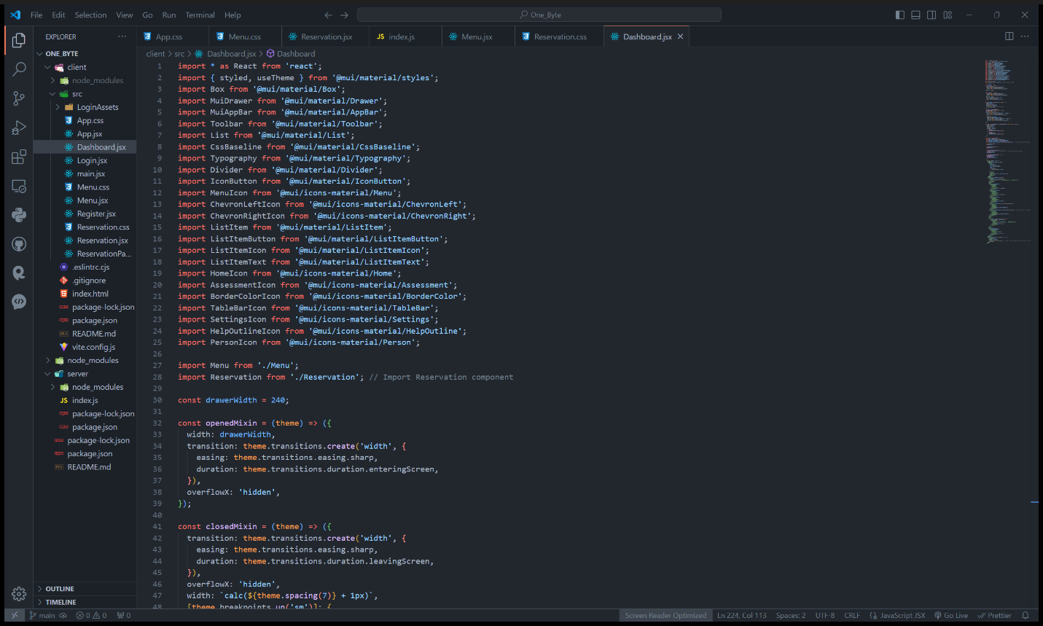

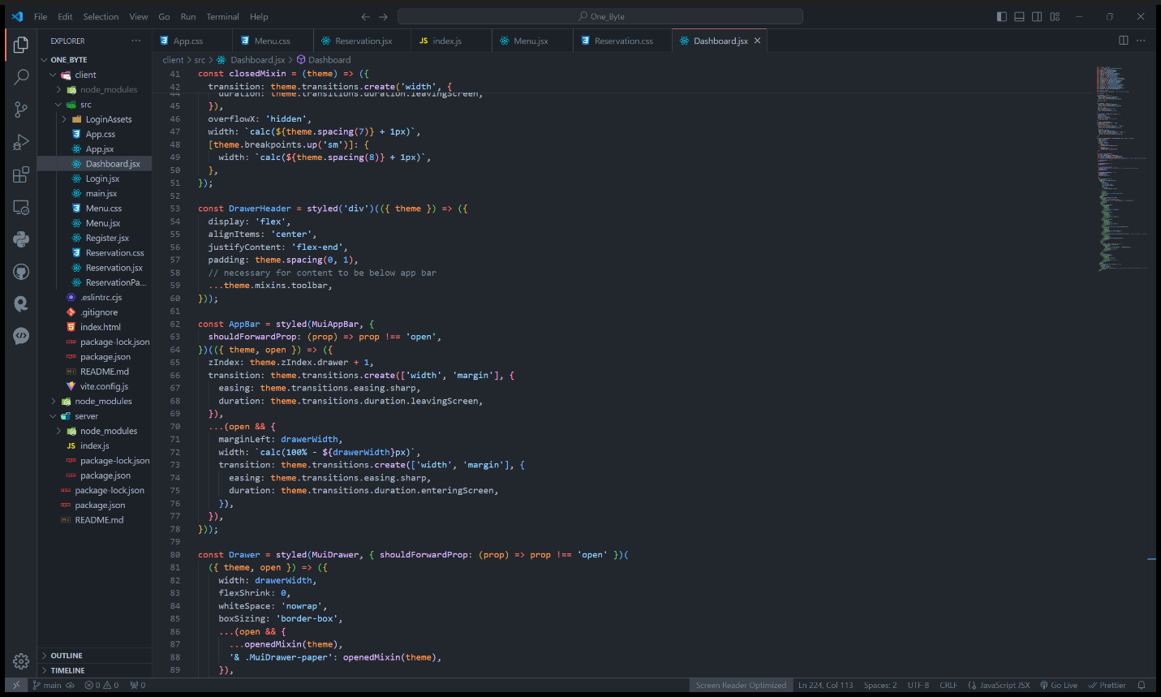

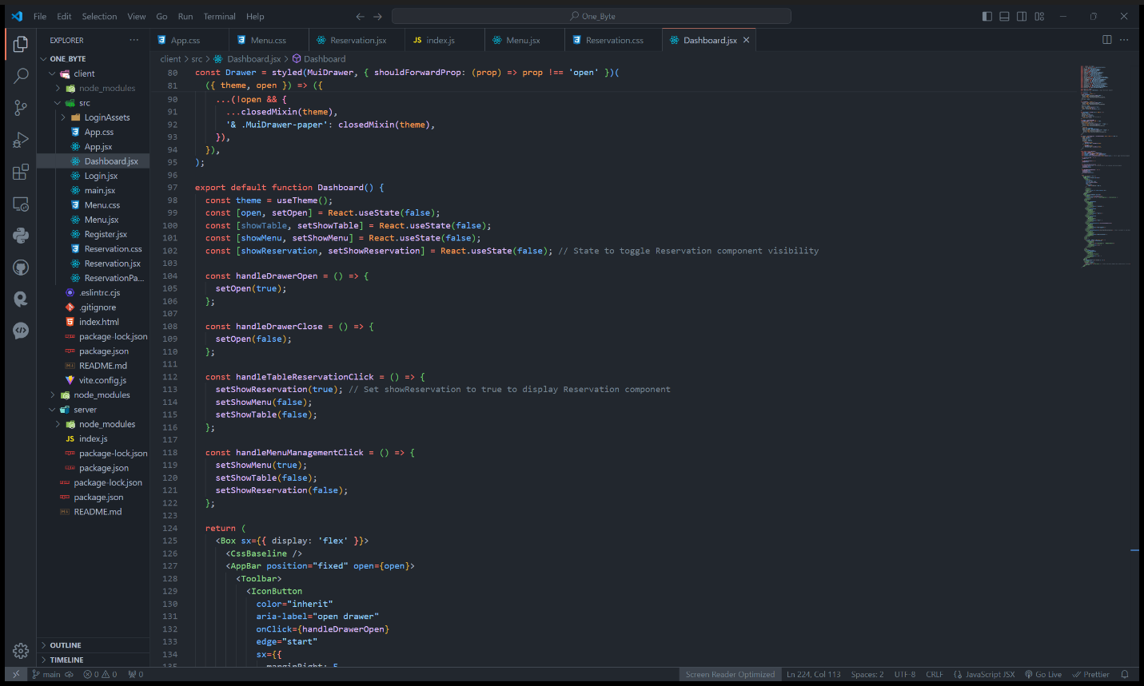

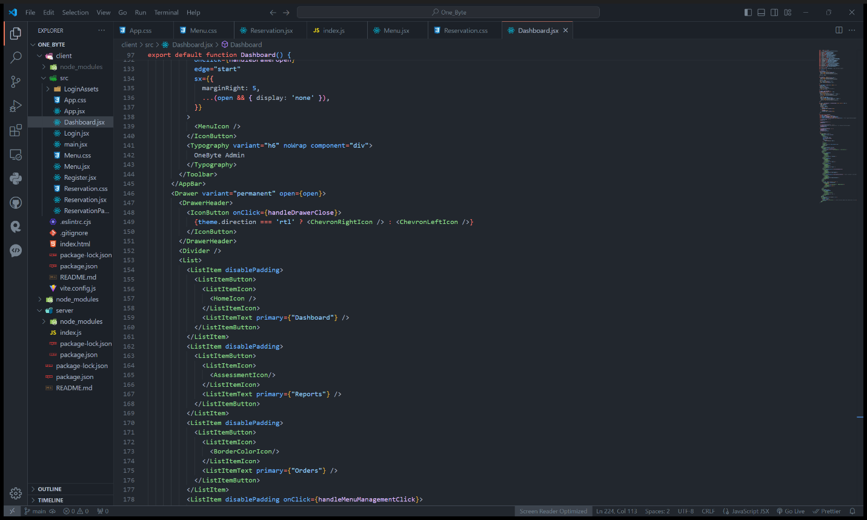

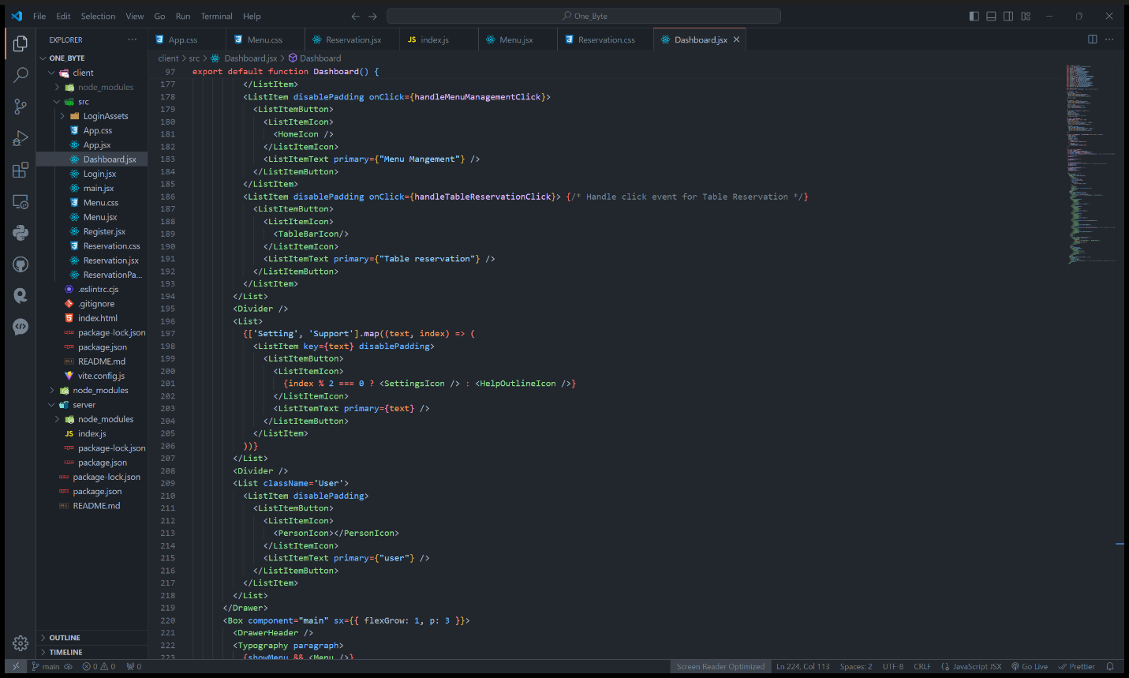

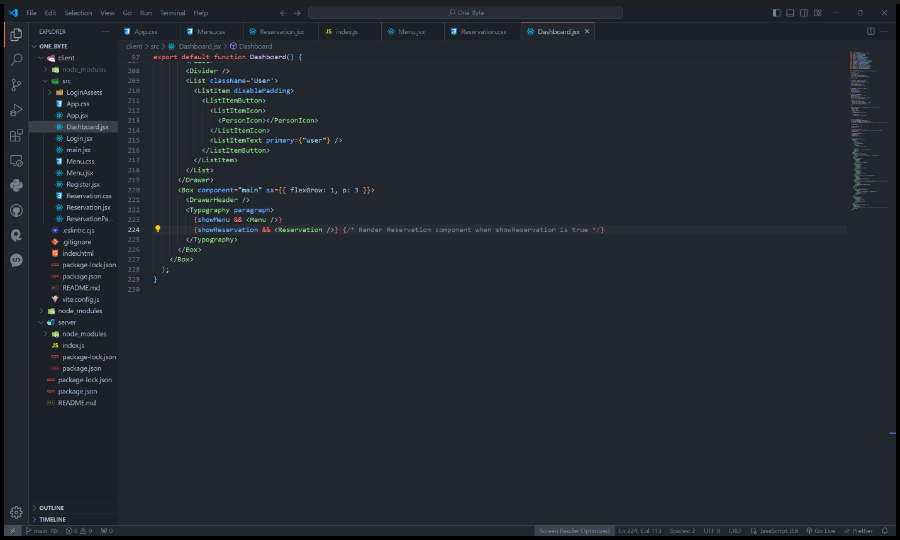

Here, it provides different features to navigation, Sidebar, AppBar, Drawer, Main Content Area, and User Profile.

Sidebar Navigation:

The component features a sidebar navigation menu that opens and closes using the MenuIcon button in the app bar. It contains various menu items such as Dashboard, Reports, Orders, Menu Management, Table Reservation, Settings, and Support. Each menu item is represented by an icon and text, and clicking on them triggers different actions or displays relevant content.

AppBar:

The AppBar component at the top of the page displays the OneByte Admin title and includes a MenuIcon button for opening the sidebar.

Drawer:

The Drawer component represents the sidebar navigation menu. It includes a header with a ChevronLeftIcon button for closing the sidebar when it's open. The sidebar content consists of menu items organized into lists, with icons and text labels. Clicking on a menu item triggers specific actions, such as displaying different components or navigating to different pages.

Main Content Area:

The main content area displays the content corresponding to the selected menu item. When a user clicks on the "Menu Management" or "Table Reservation" menu items, it sets the state to display the corresponding components (Menu or Reservation). The showMenu and showReservation states determine which component to display in the main content area.

User Profile:

At the bottom of the sidebar, there is a User Profile section displaying the currently logged-in user's information. However, it currently only shows the text "user."

Overall, the Dashboard component provides a user-friendly interface for navigating through different sections of the application and managing various functionalities such as menu management and table reservations.

Dashboard View

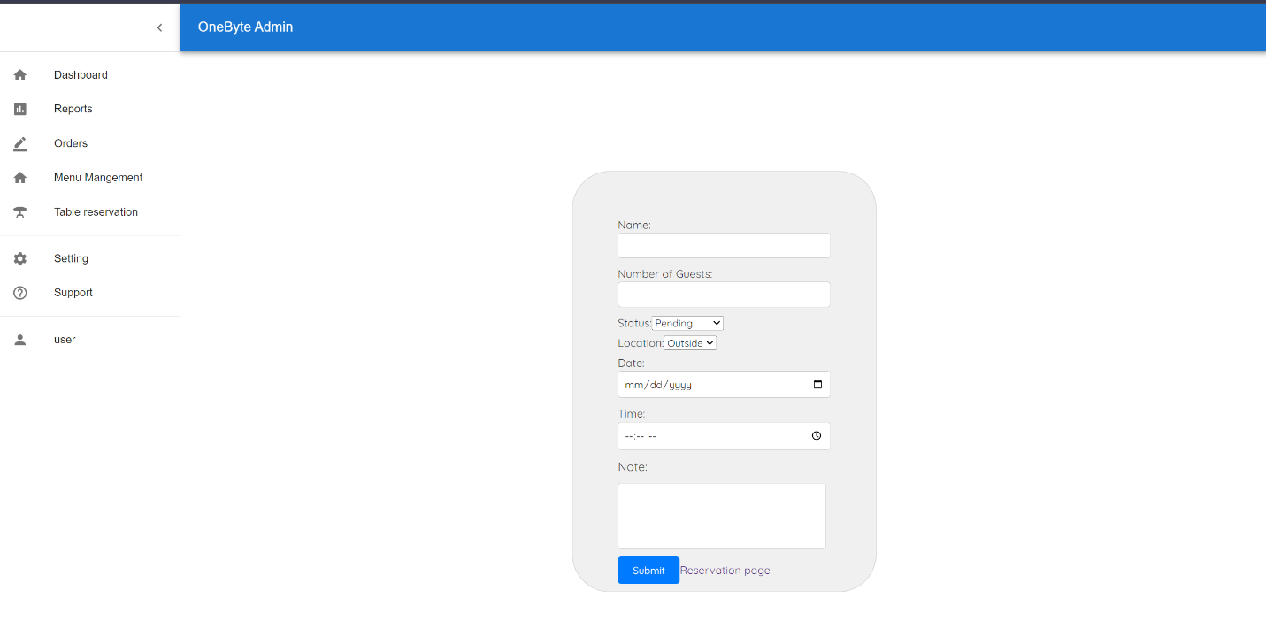

Menu Management Code

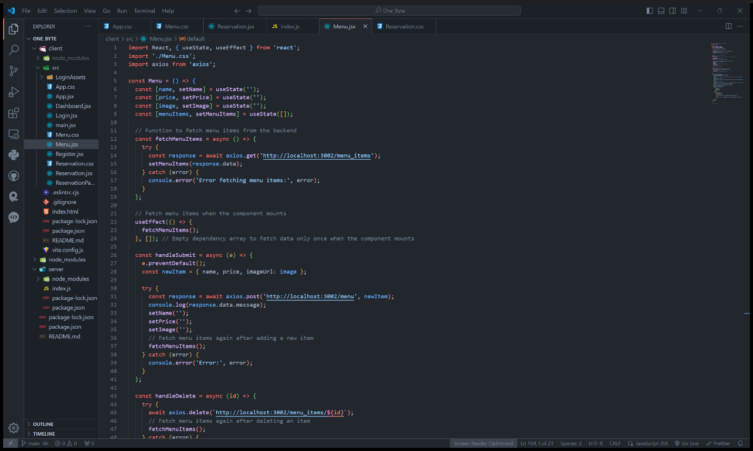

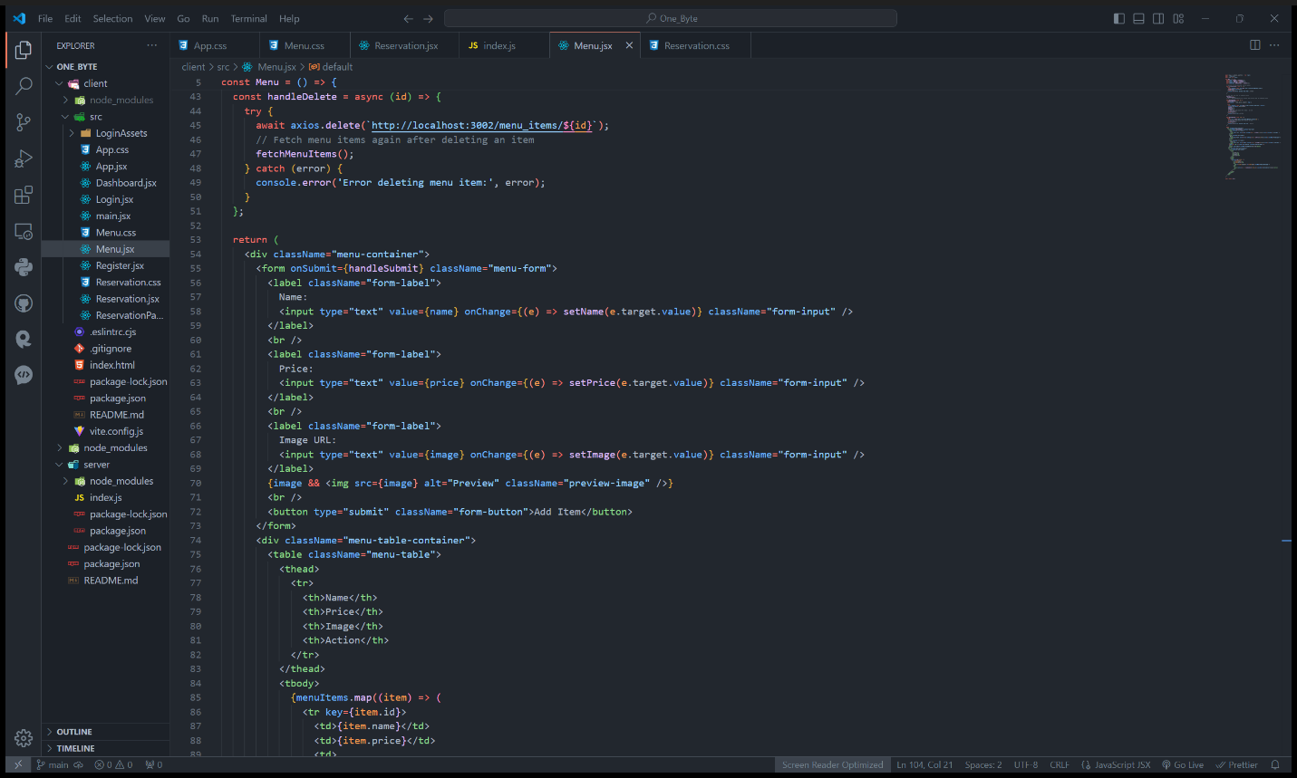

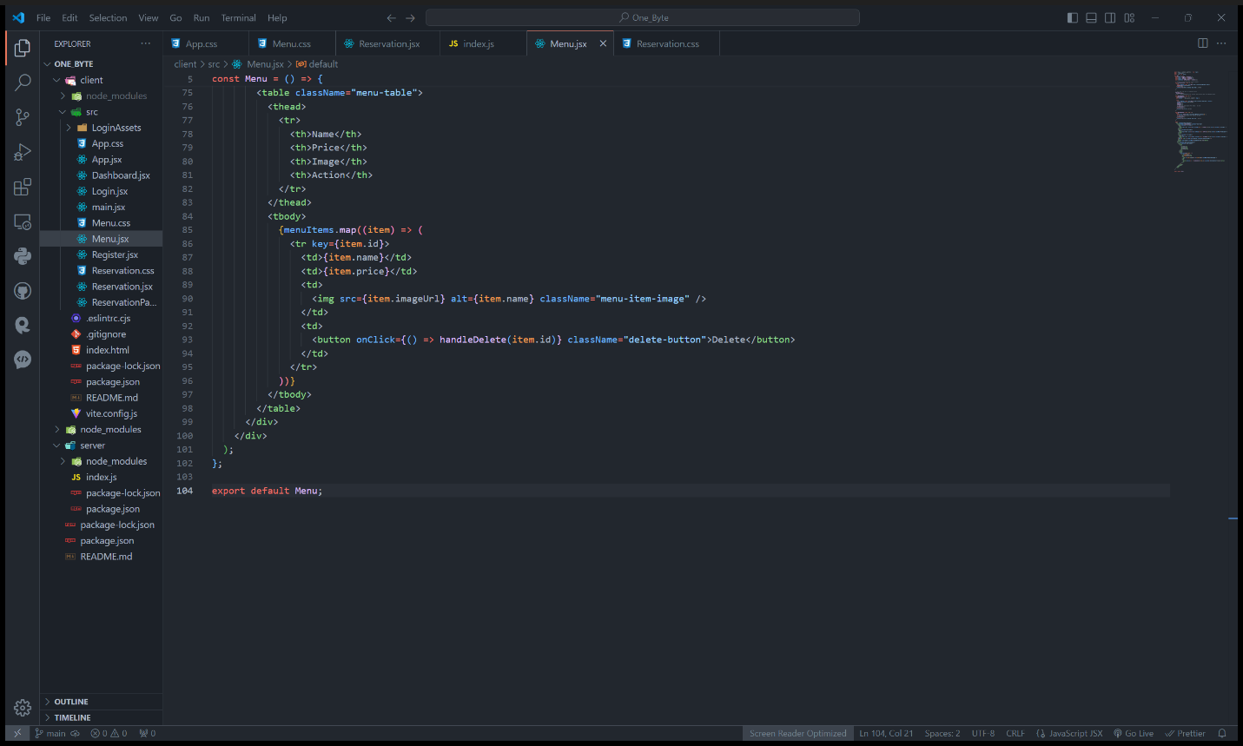

The Menu component serves as a management interface for menu items in application. State Management the component utilizes React's useState hook to manage state for name, price, image, and menuItems. name, price, and image states are used to capture input values for adding new menu items. menuItems state holds an array of menu items fetched from the backend. And Fetching Menu Items, fetchMenuItems function is an asynchronous function that makes a GET request to the backend endpoint http://localhost:3002/menu_items to fetch menu items. It updates the menuItems state with the response data. Adding Menu Items, the handleSubmit function is triggered when the user submits the form to add a new menu item. It constructs a new menu item object from the input values (name, price, and image) and sends a POST request to the backend endpoint http://localhost:3002/menu to add the item. After successfully adding the item, it resets the input fields and fetches menu items again to update the list. Deleting Menu Items, the handleDelete function is called when the user clicks the "Delete" button next to a menu item. It sends a DELETE request to the backend endpoint http://localhost:3002/menu_items/:id to delete the corresponding menu item. After successful deletion, it fetches menu items again to update the list. Rendering, Menu Items the component renders a form for adding new menu items with input fields for name, price, and image URL. It also displays a preview of the image if an image URL is provided. Below the form, it renders a table to display existing menu items fetched from the backend. Each menu item is displayed in a table row with columns for name, price, image, and a "Delete" button to remove the item. Overall the Menu component provides an interface for restaurant administrators to manage their menu items efficiently, allowing them to add new items, view existing items, and delete items as needed.

Menu Management Database

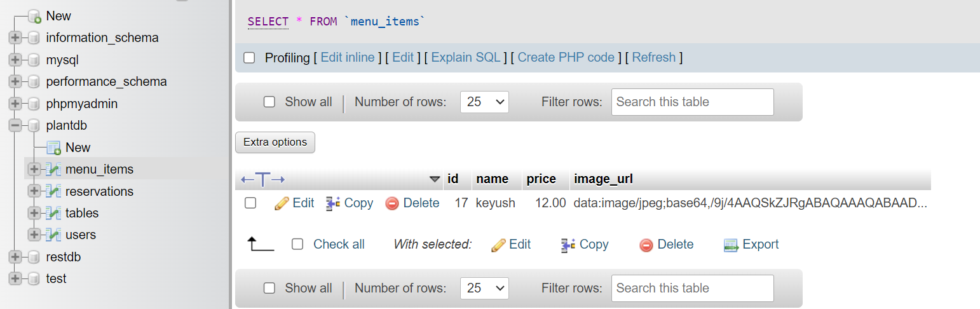

Menu Management View

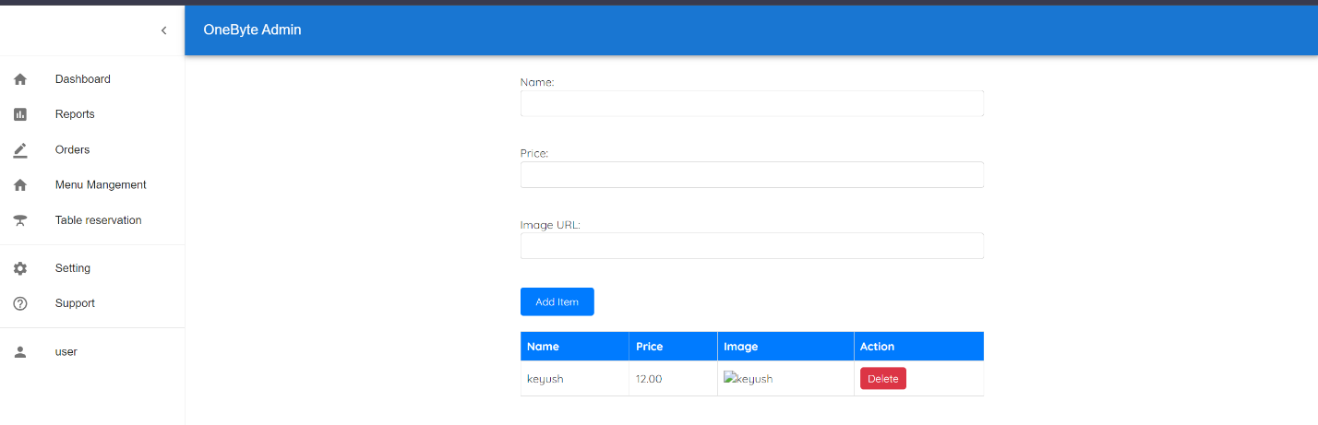

Table Reservation Code

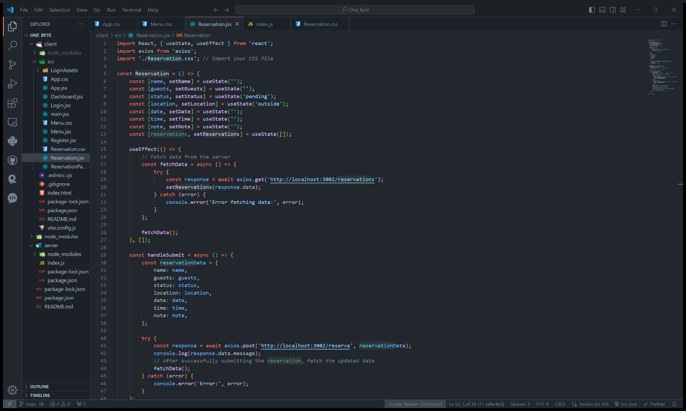

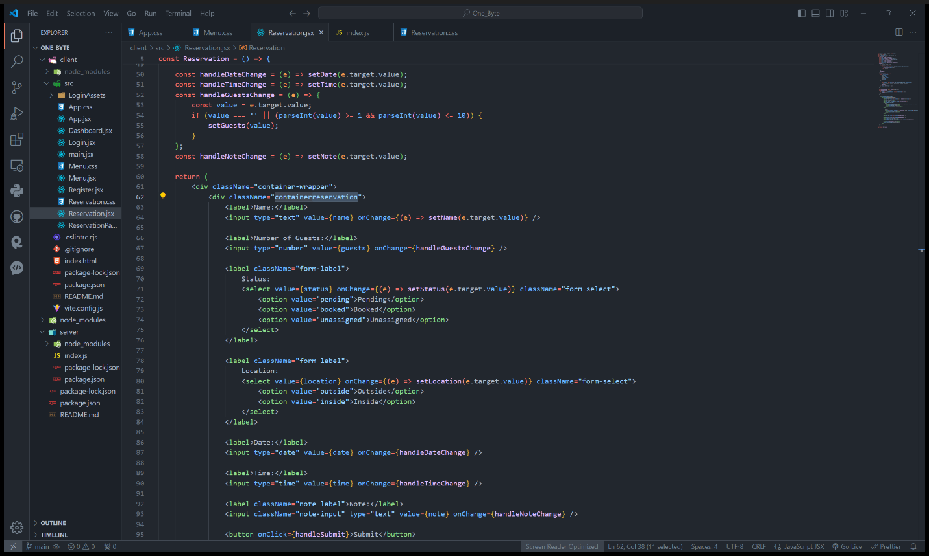

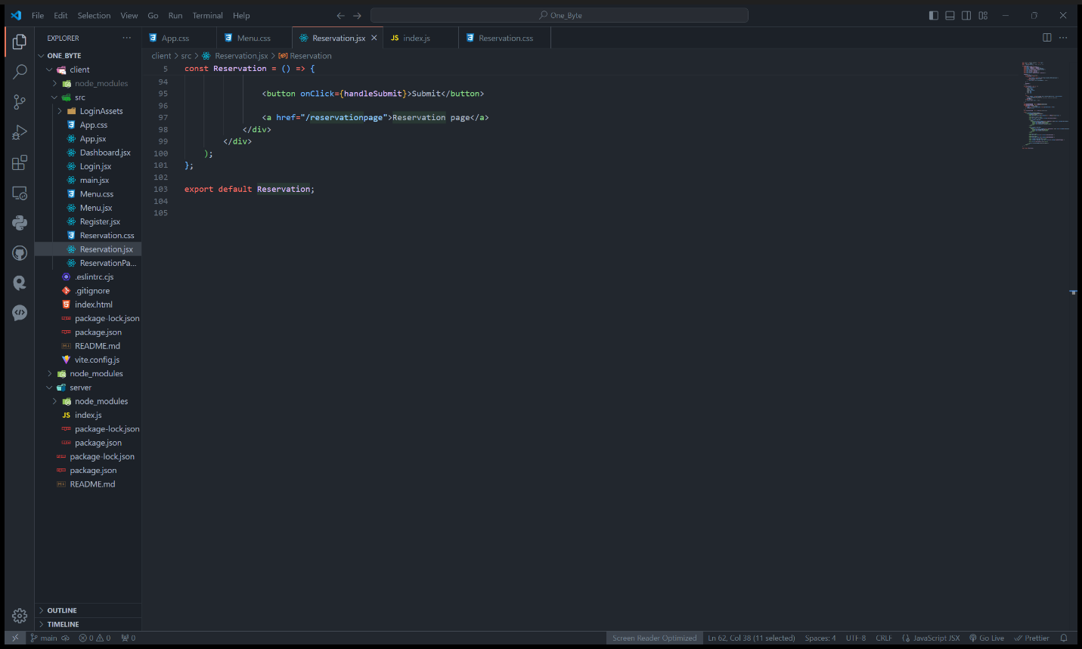

This reservation page is for handling reservations. Which includes form inputs for capturing details such as name, number of guests, status, location, date, time, and a note. Additionally, it fetches existing reservations from the server upon component mount and provides functionality to submit new reservations. Initializes state variables using the useState hook to manage form inputs and reservations data. Uses the useEffect hook to fetch existing reservations from the server when the component mounts. Defines event handlers for form input changes and submission of new reservations. Renders form inputs for capturing reservation details and a button to submit the reservation. Provides links to navigate to other pages related to reservations.

The reservation functionality for backend code has two endpoint reserve and reservations: Where reserve endpoint handles POST requests for making a reservation. It expects the following fields in the request body: name, guests, status, location, date, time, note. Upon receiving the request, it inserts the reservation data into the reservations table in the MySQL database. If the insertion is successful, it sends back a success message in the response. If there's an error during the insertion, it sends back a 500 status along with an error message. And reservations endpoint handles GET requests to fetch all existing reservations. It queries the reservations table in the MySQL database to retrieve all reservation data. If the query is successful, it sends back the reservation data in the response. If there's an error during the query, it sends back a 500 status along with an error message.

Table Reservation Form



Table Reservation Database

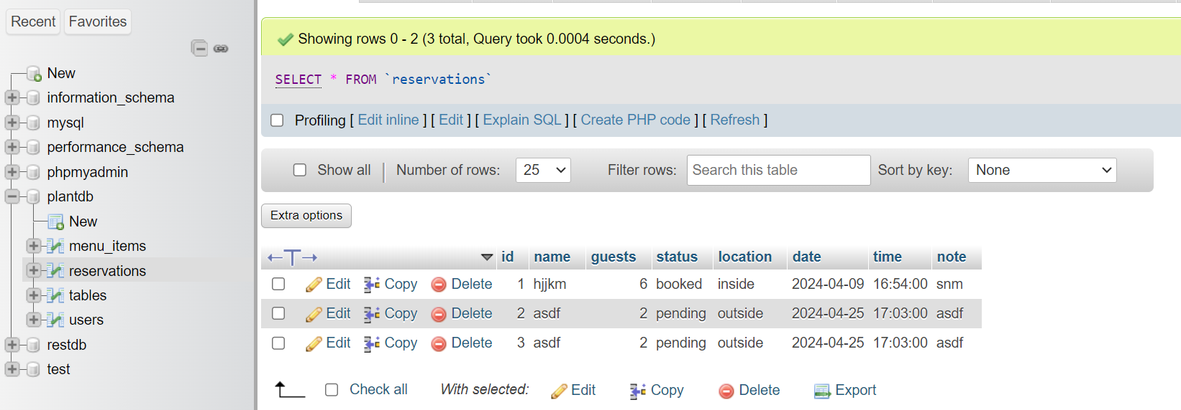

Table ReservationPage Code

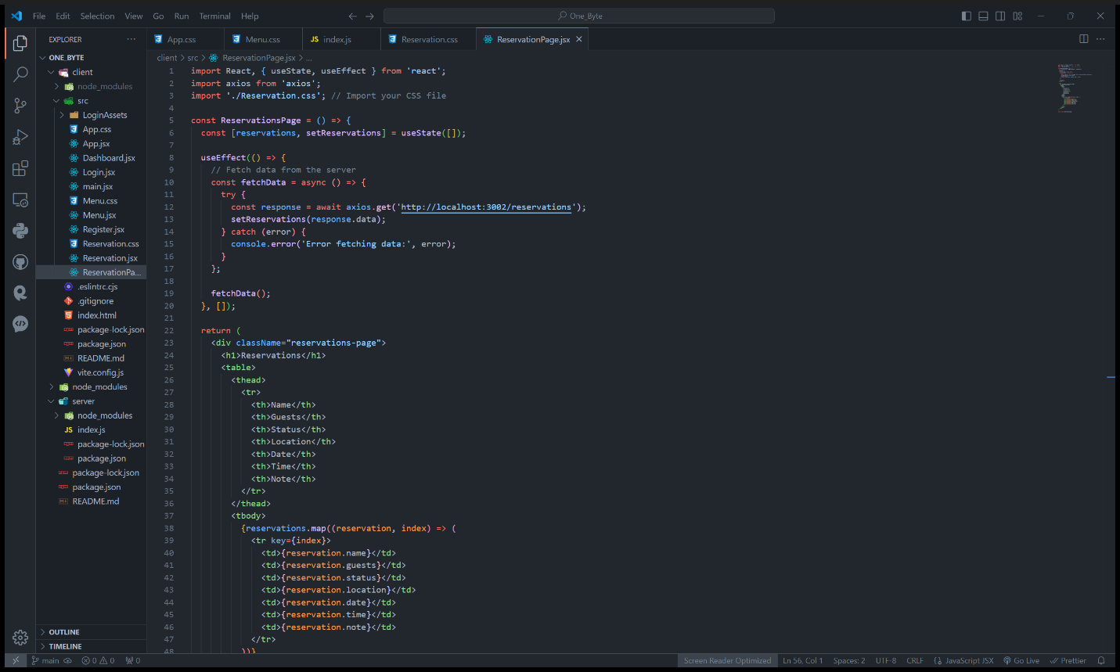

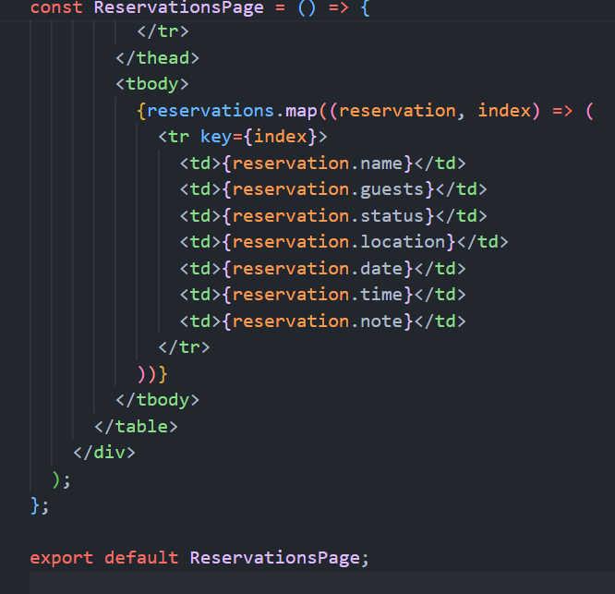

This reservation page is responsible for displaying the list of reservations. It initializes a state variable, reservations to store the fetched reservation data. Utilizes the useEffect hook to fetch reservation data from the server when the component mounts. Renders a table to display reservation information, including name, guests, status, location, date, time, and note. And for server-side server is created using Express on port 3002. MySQL database connection is established using the mysql2 library. Two endpoints are defined reserve and reservations. Where reserve endpoint handles the insertion of reservation data into the database. It expects the reservation details (name, guests, status, location, date, time, note) in the request body and inserts them into the reservations table. And reservations endpoint fetches all reservation data from the reservations table and returns it as a JSON response.

Table ReservationPage view

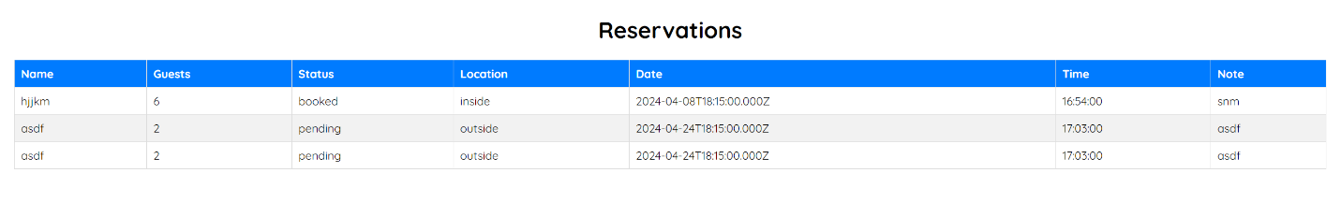

## 2.Use of Version control (Screenshots of logs)

**Push and Commits**

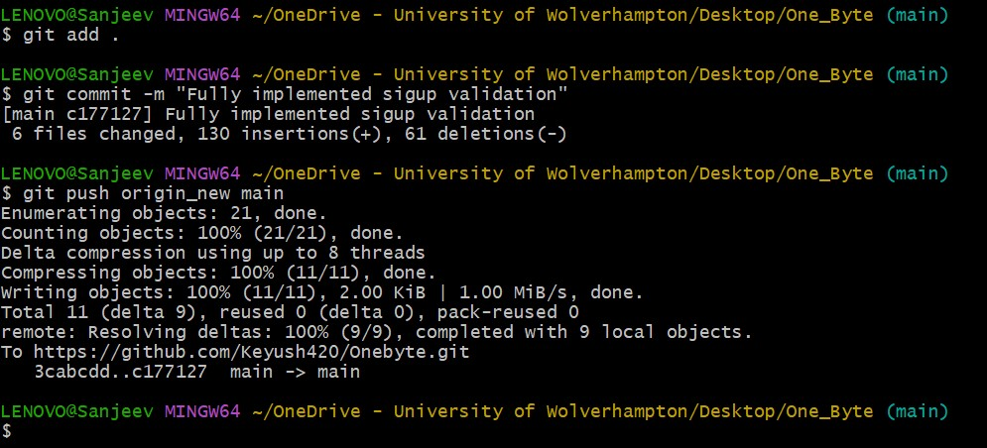

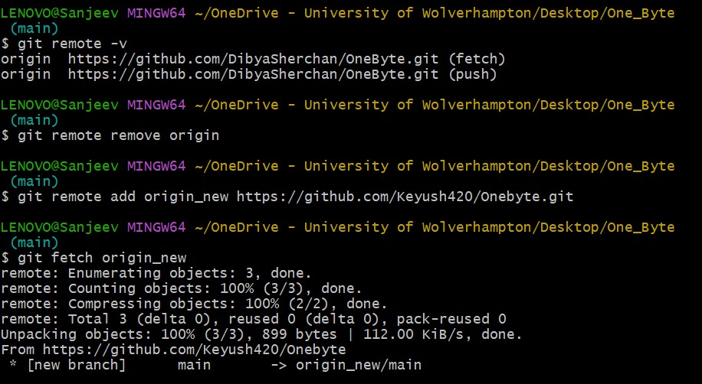

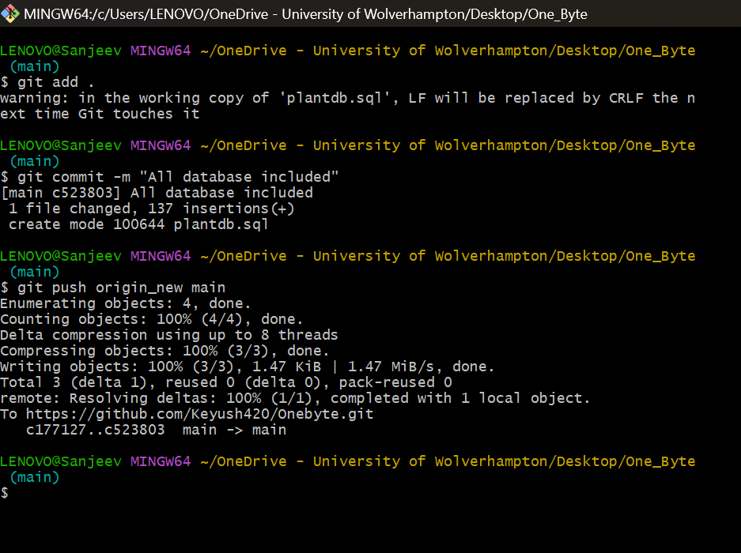

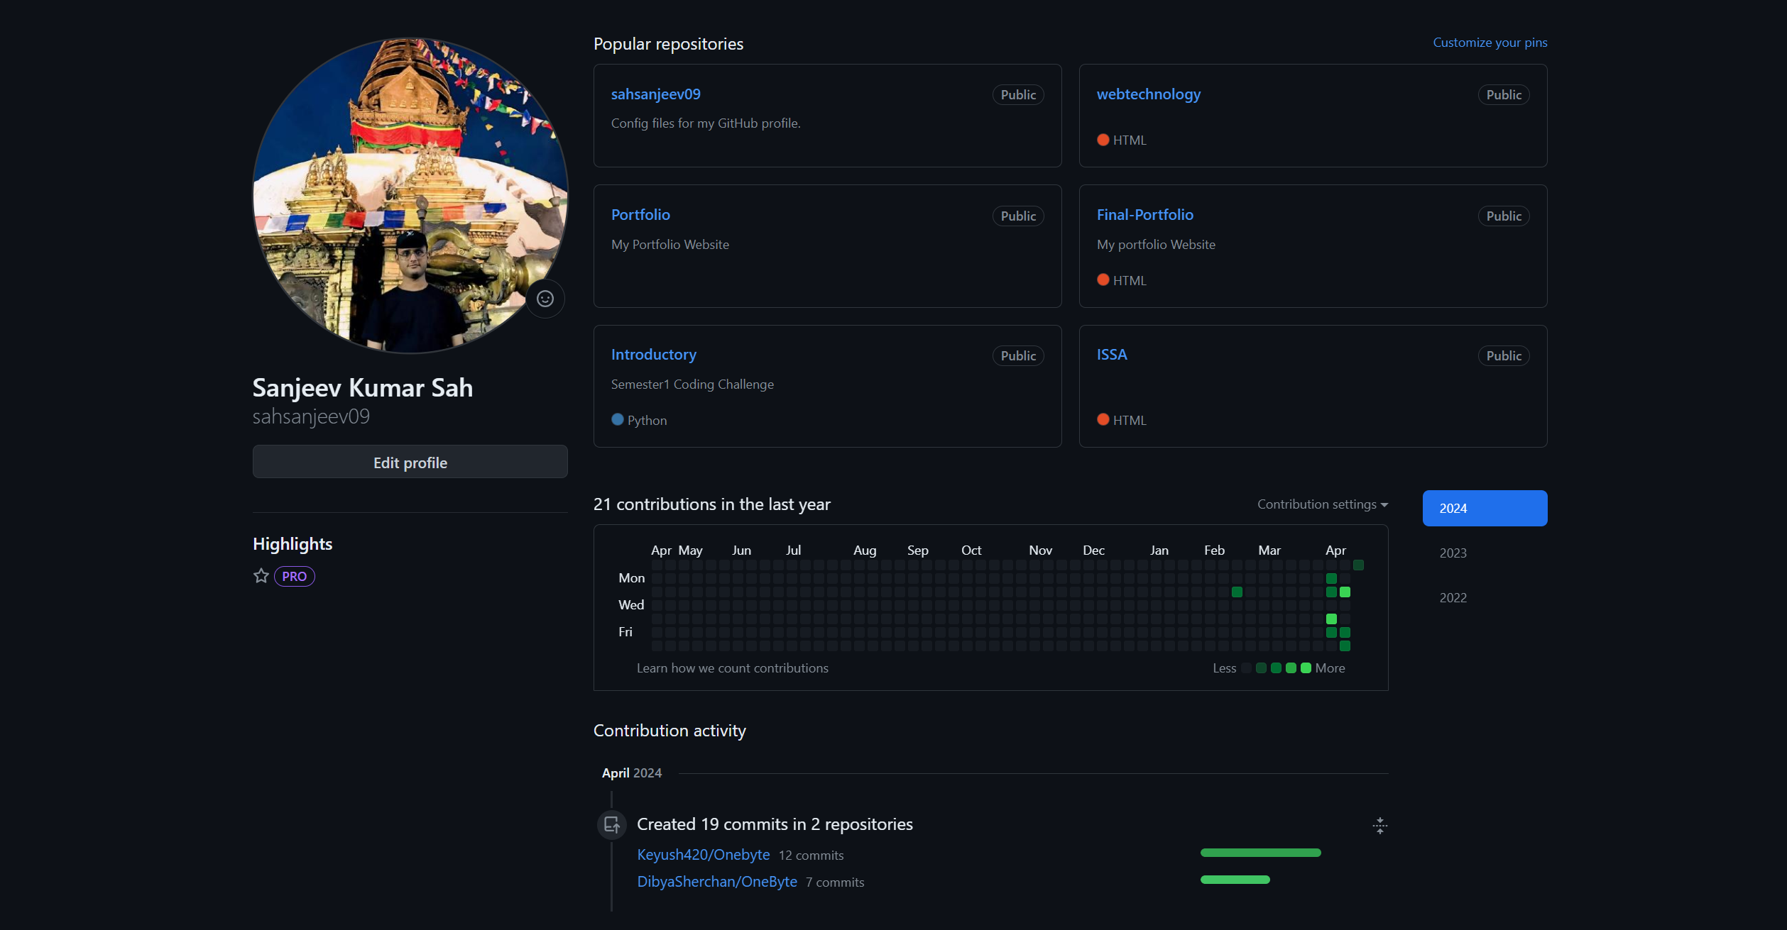

**Appendix C**

**Good Communication and File Sharing**

**Jira-Board**

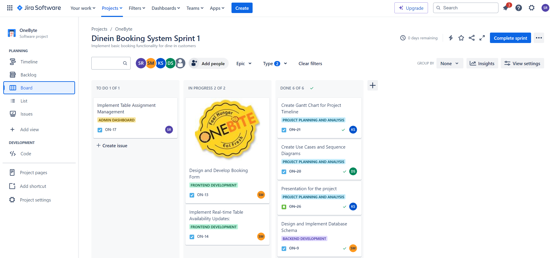

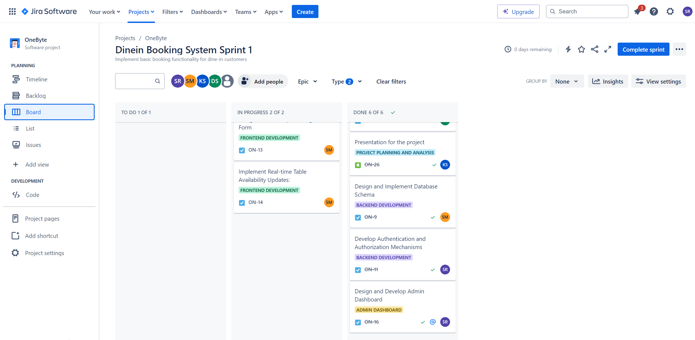

**Jira-Backlog**

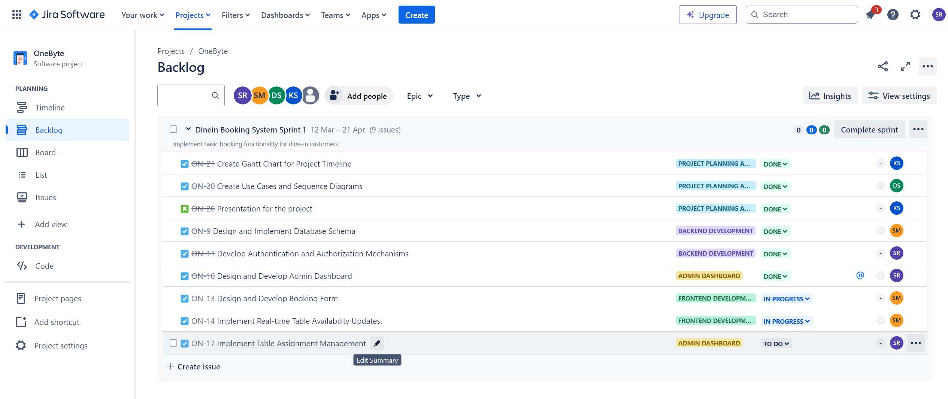

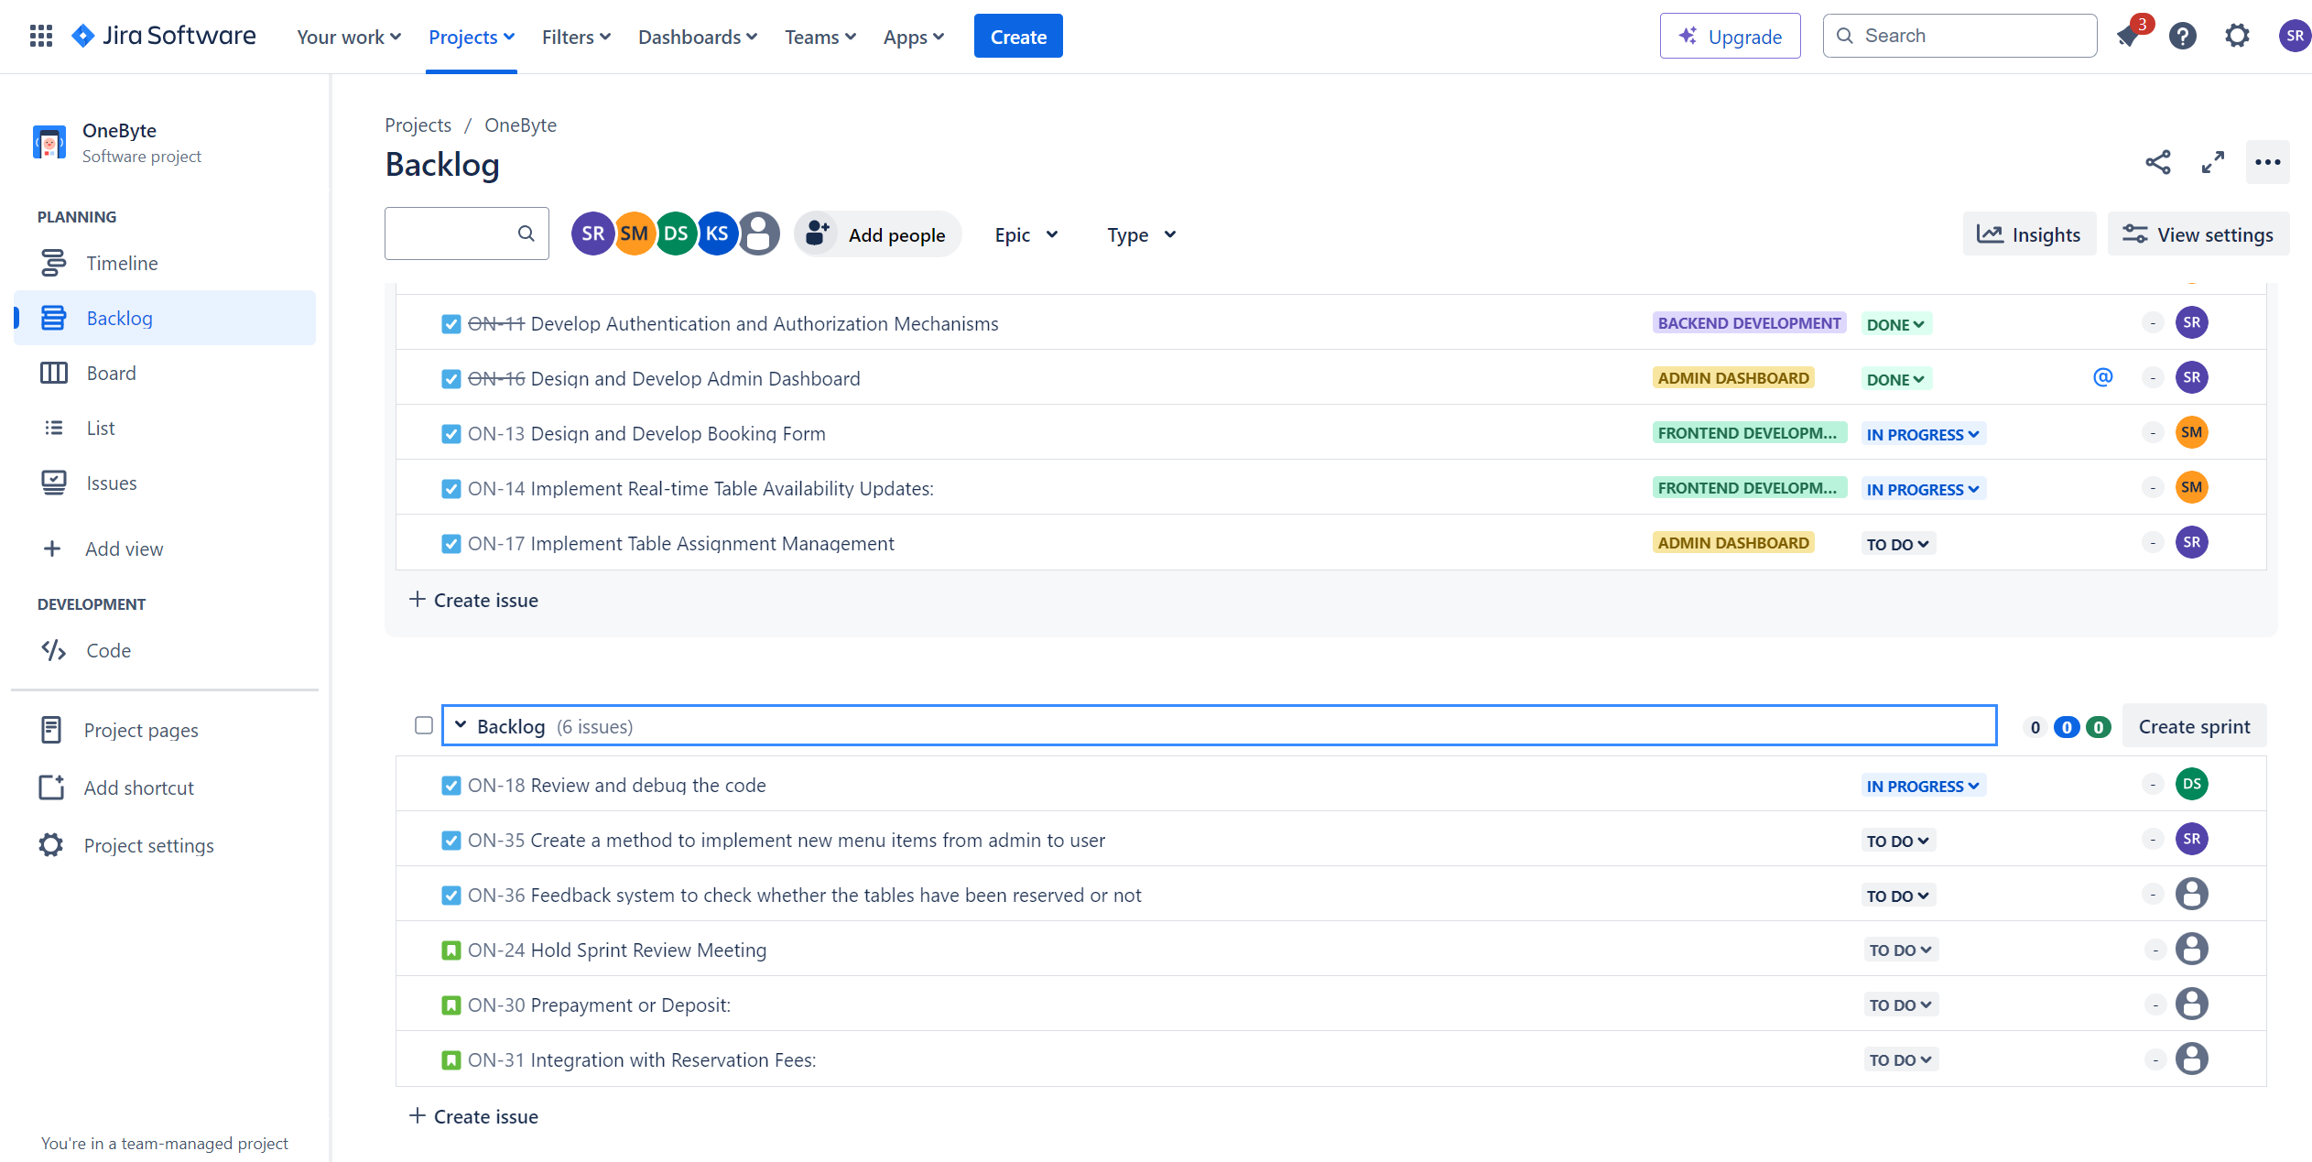

**Jira-List**

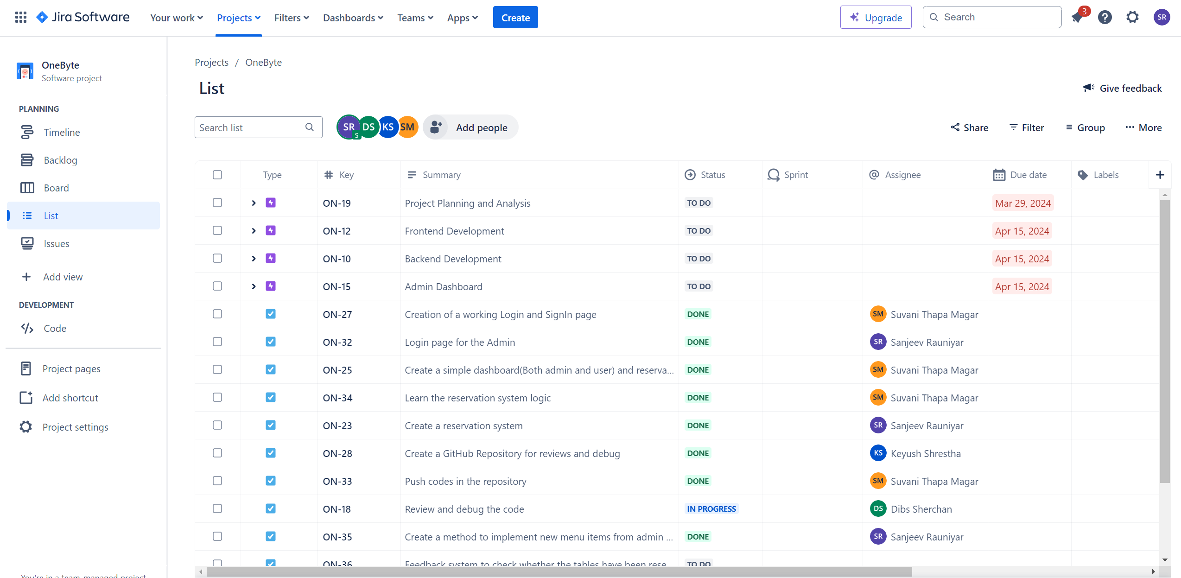

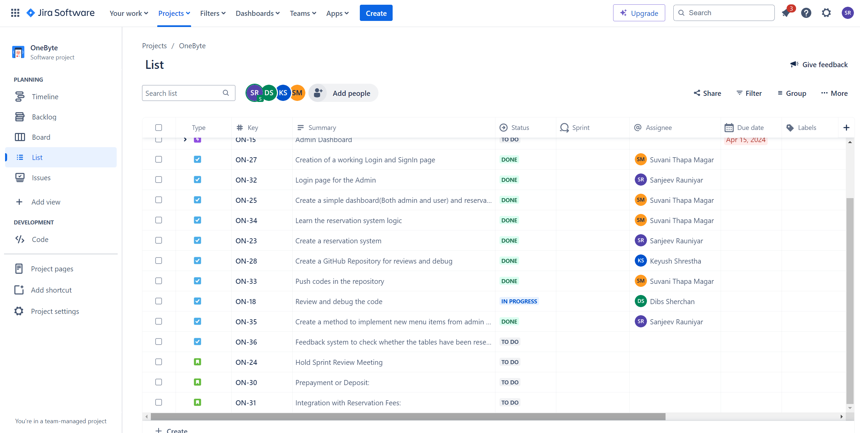

**Google Space**

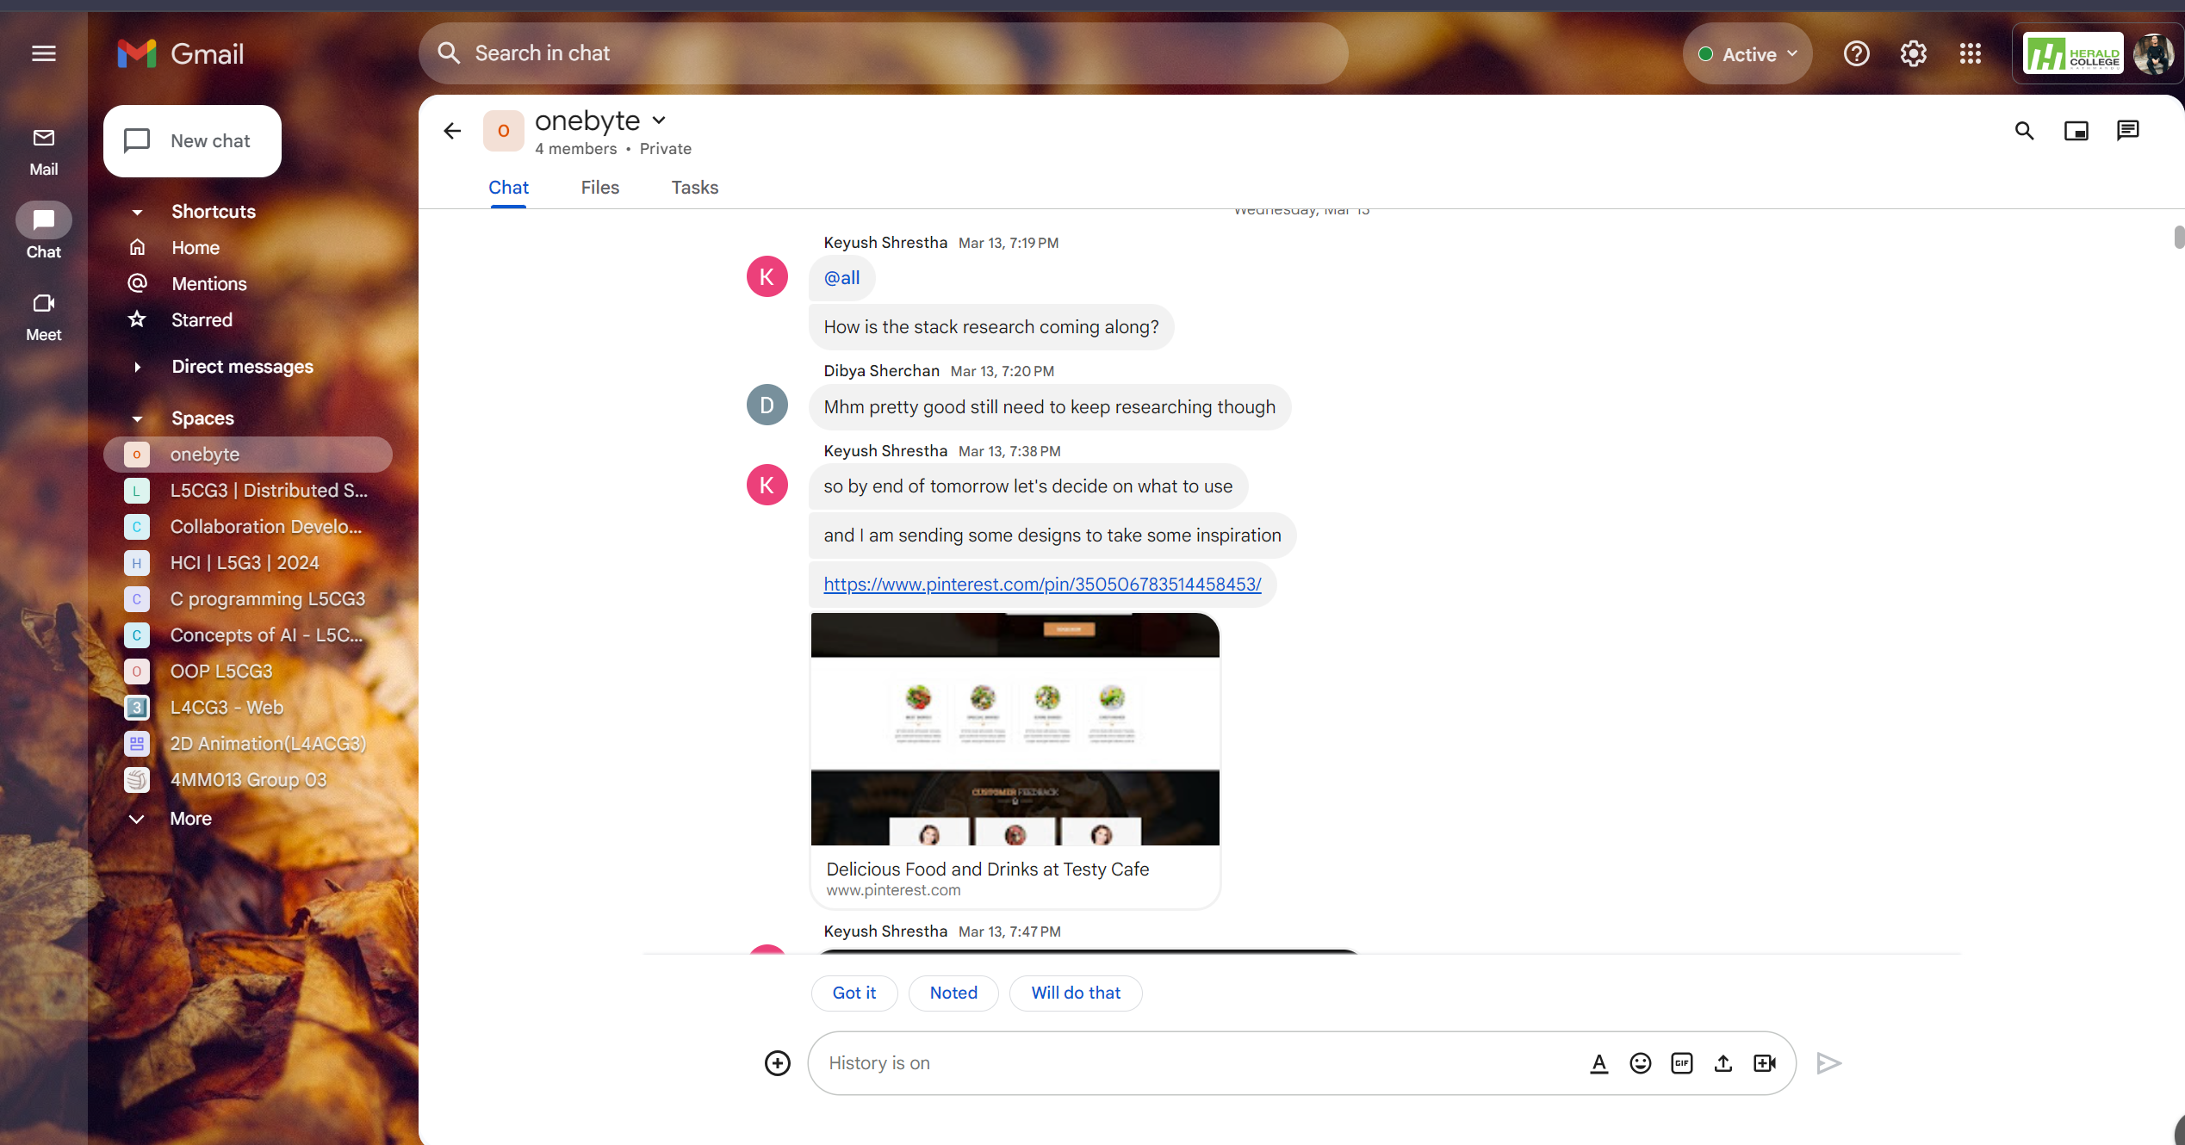

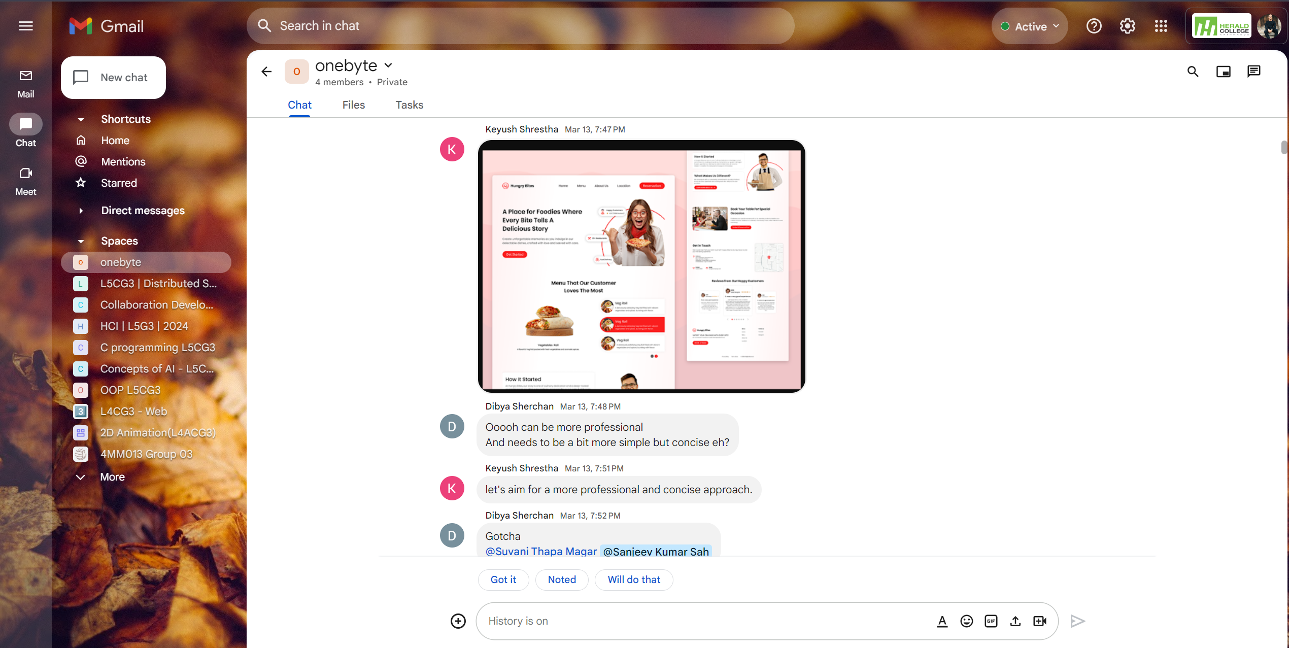

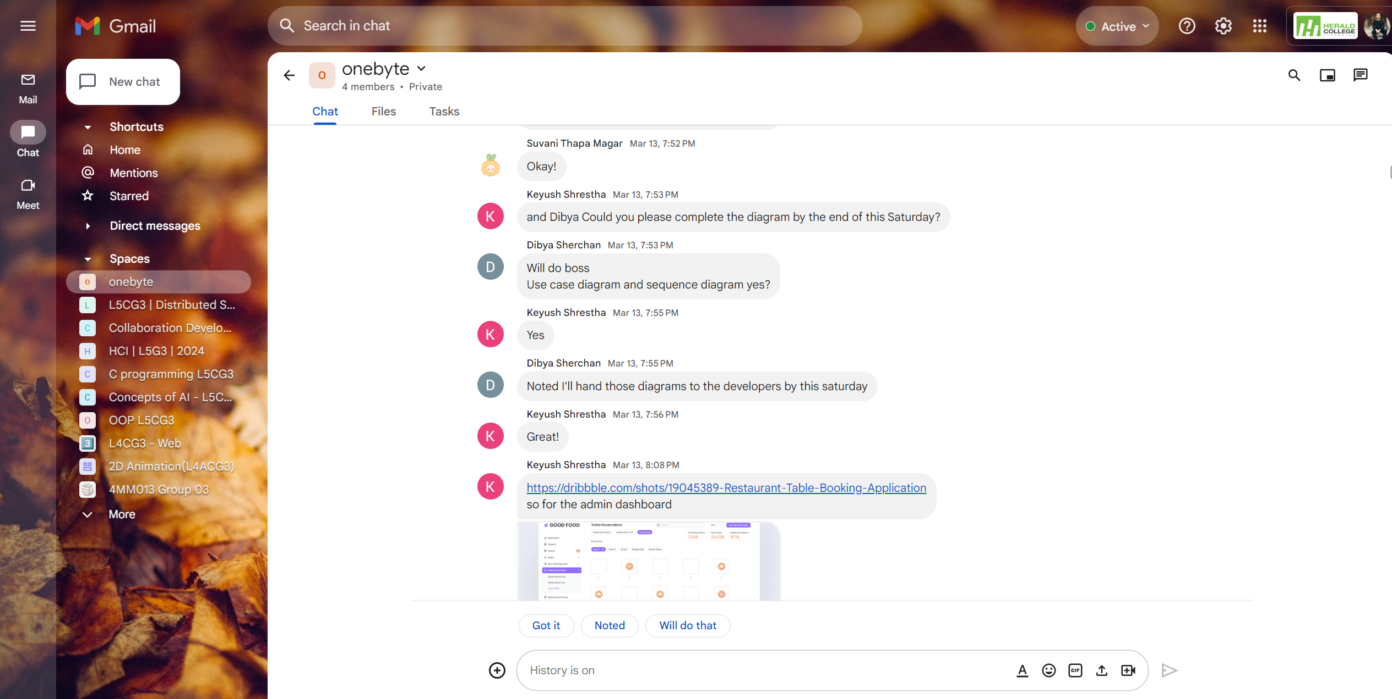

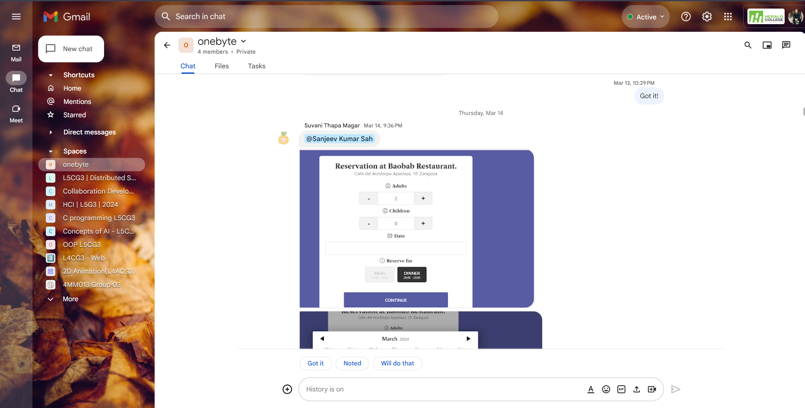

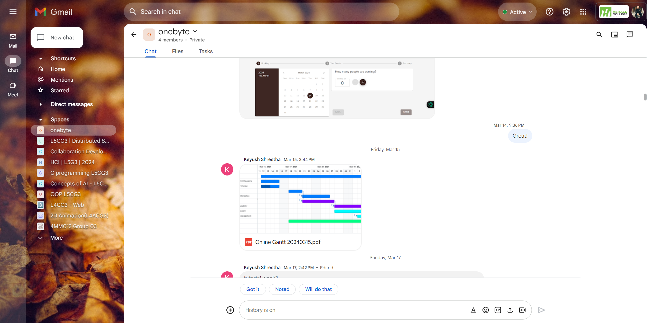

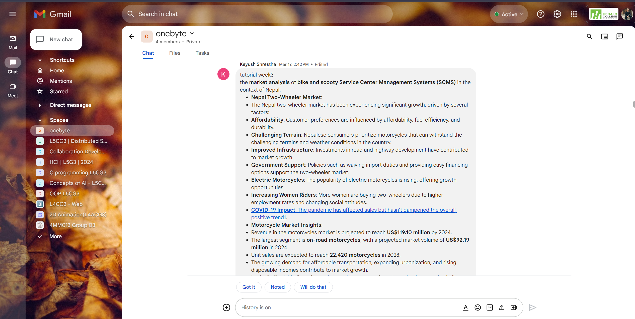

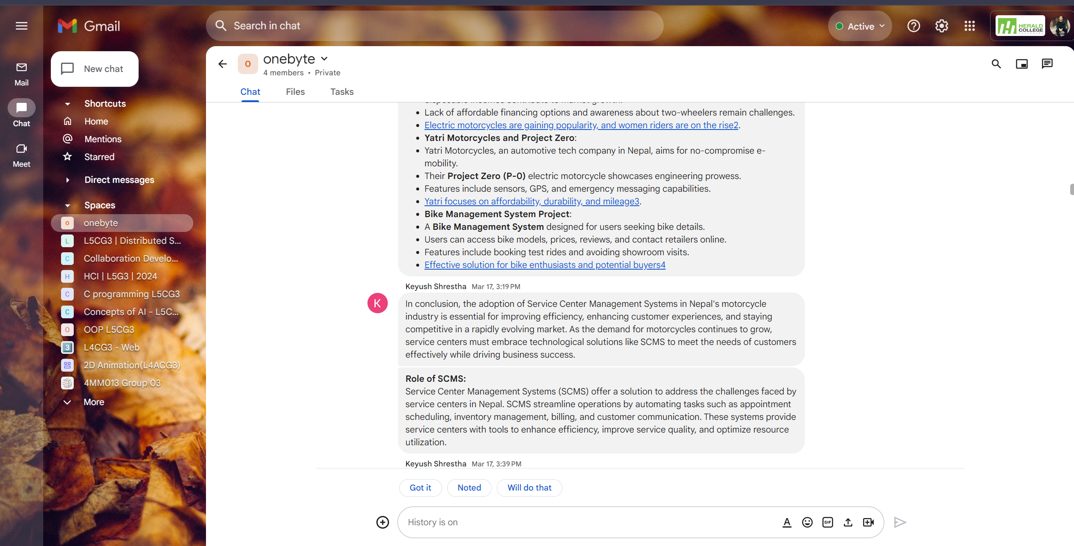

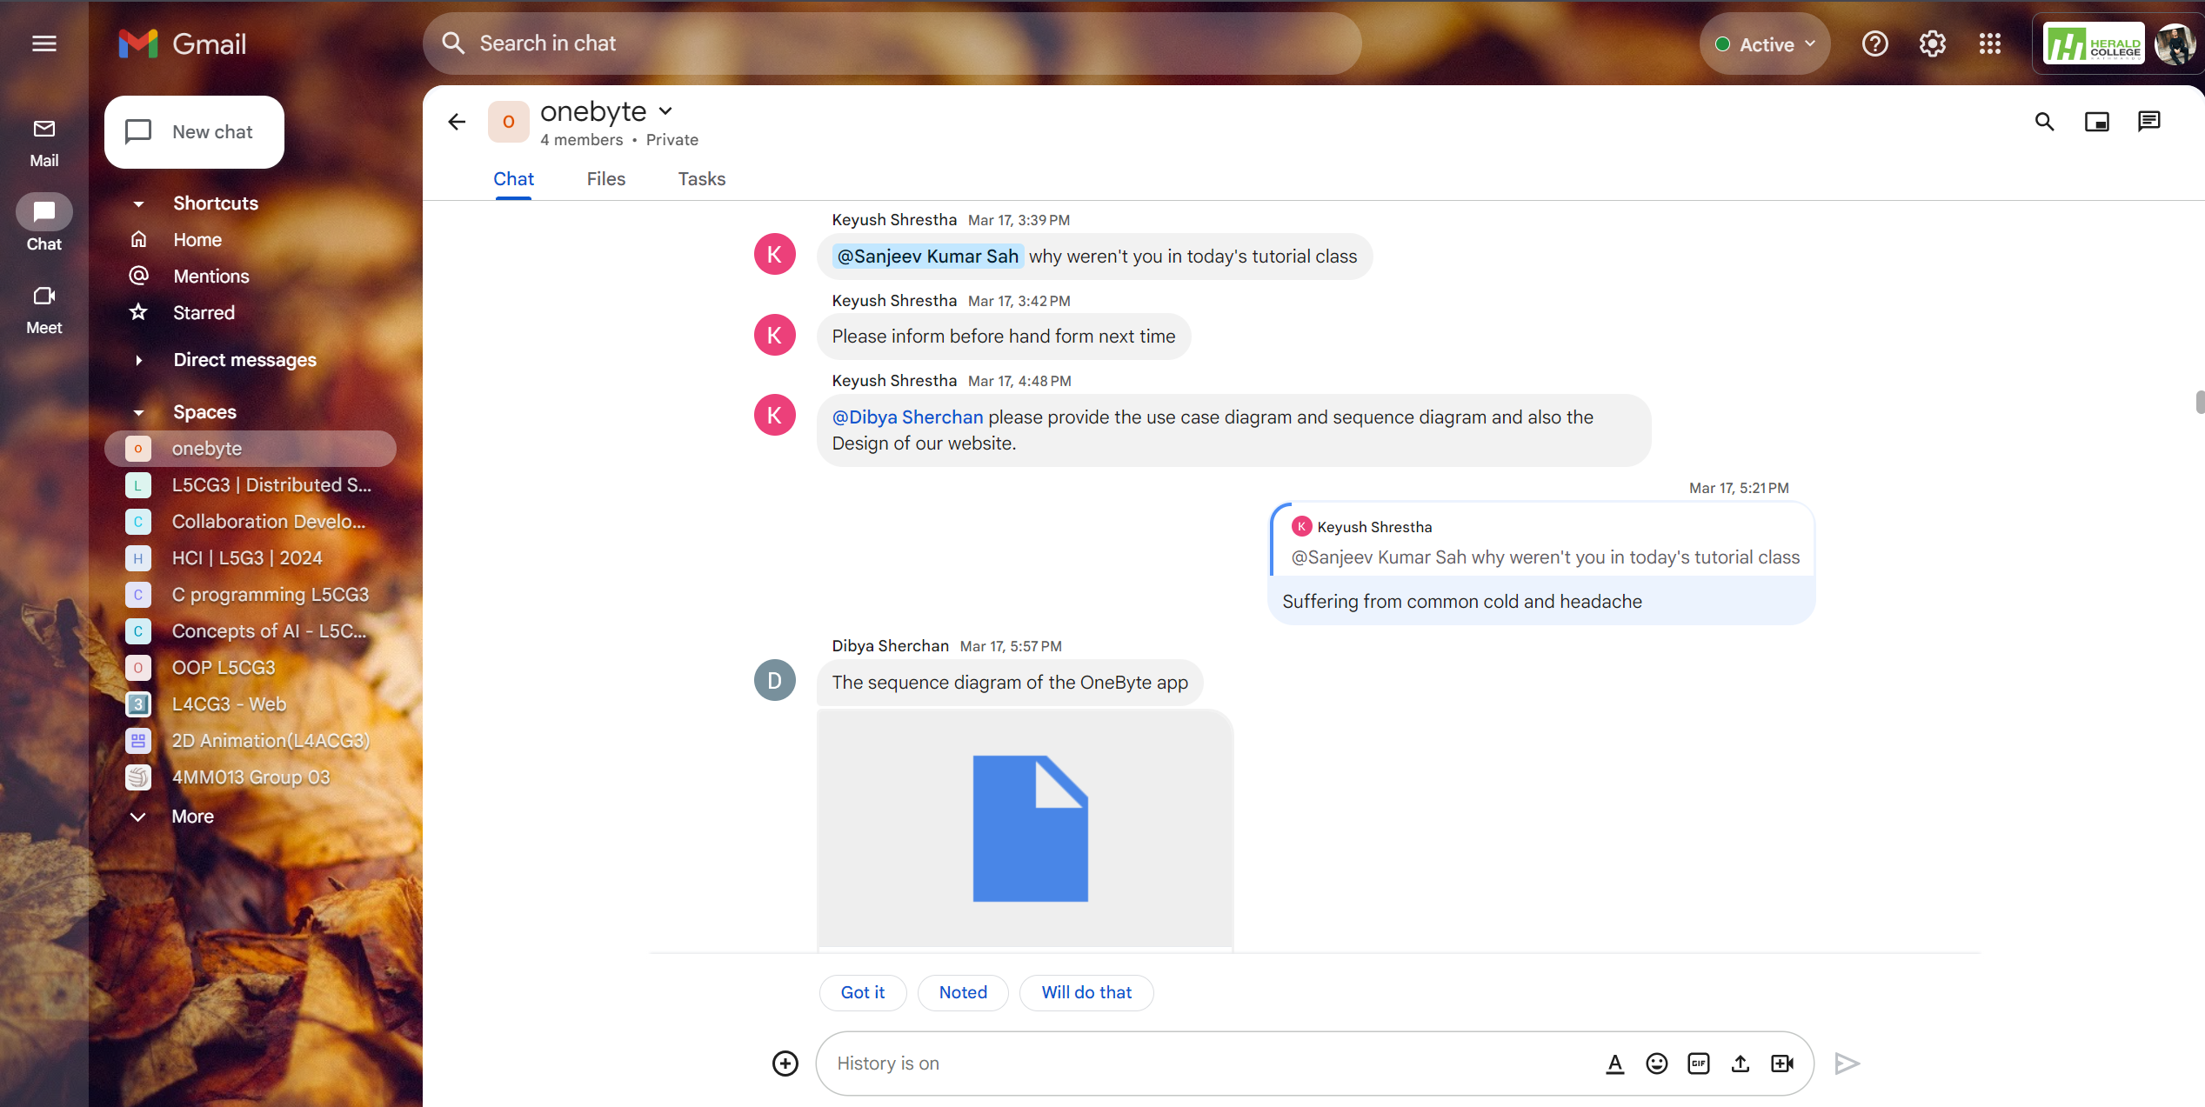

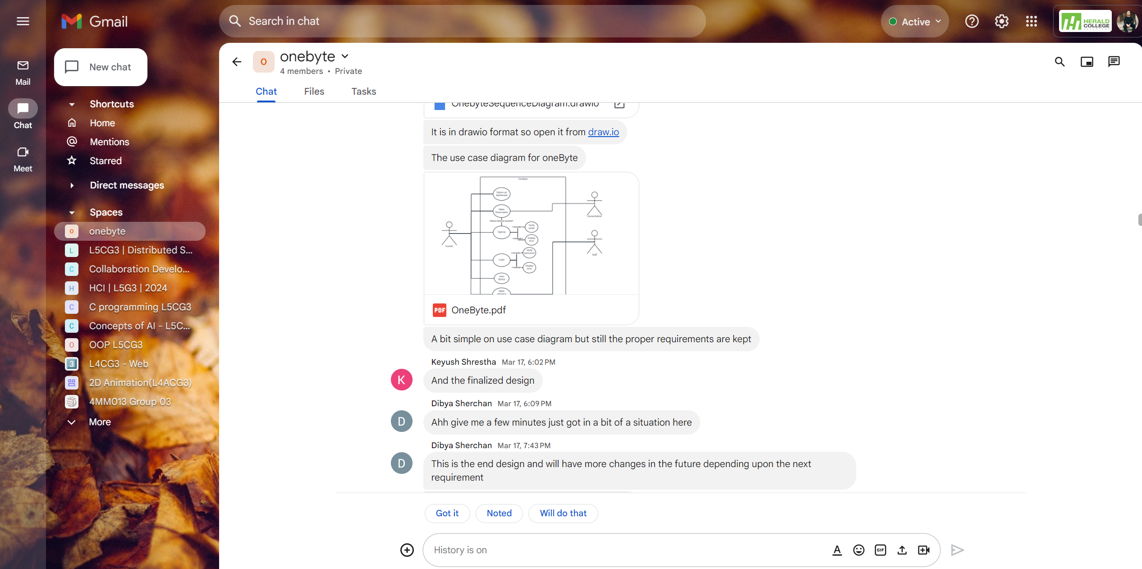

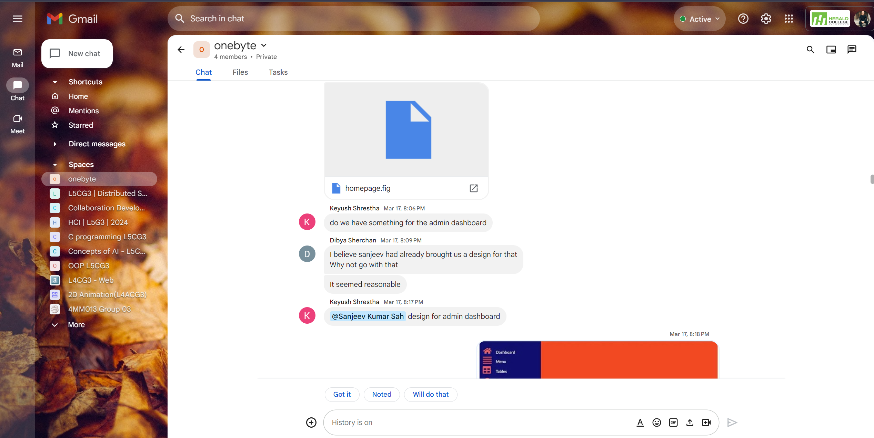

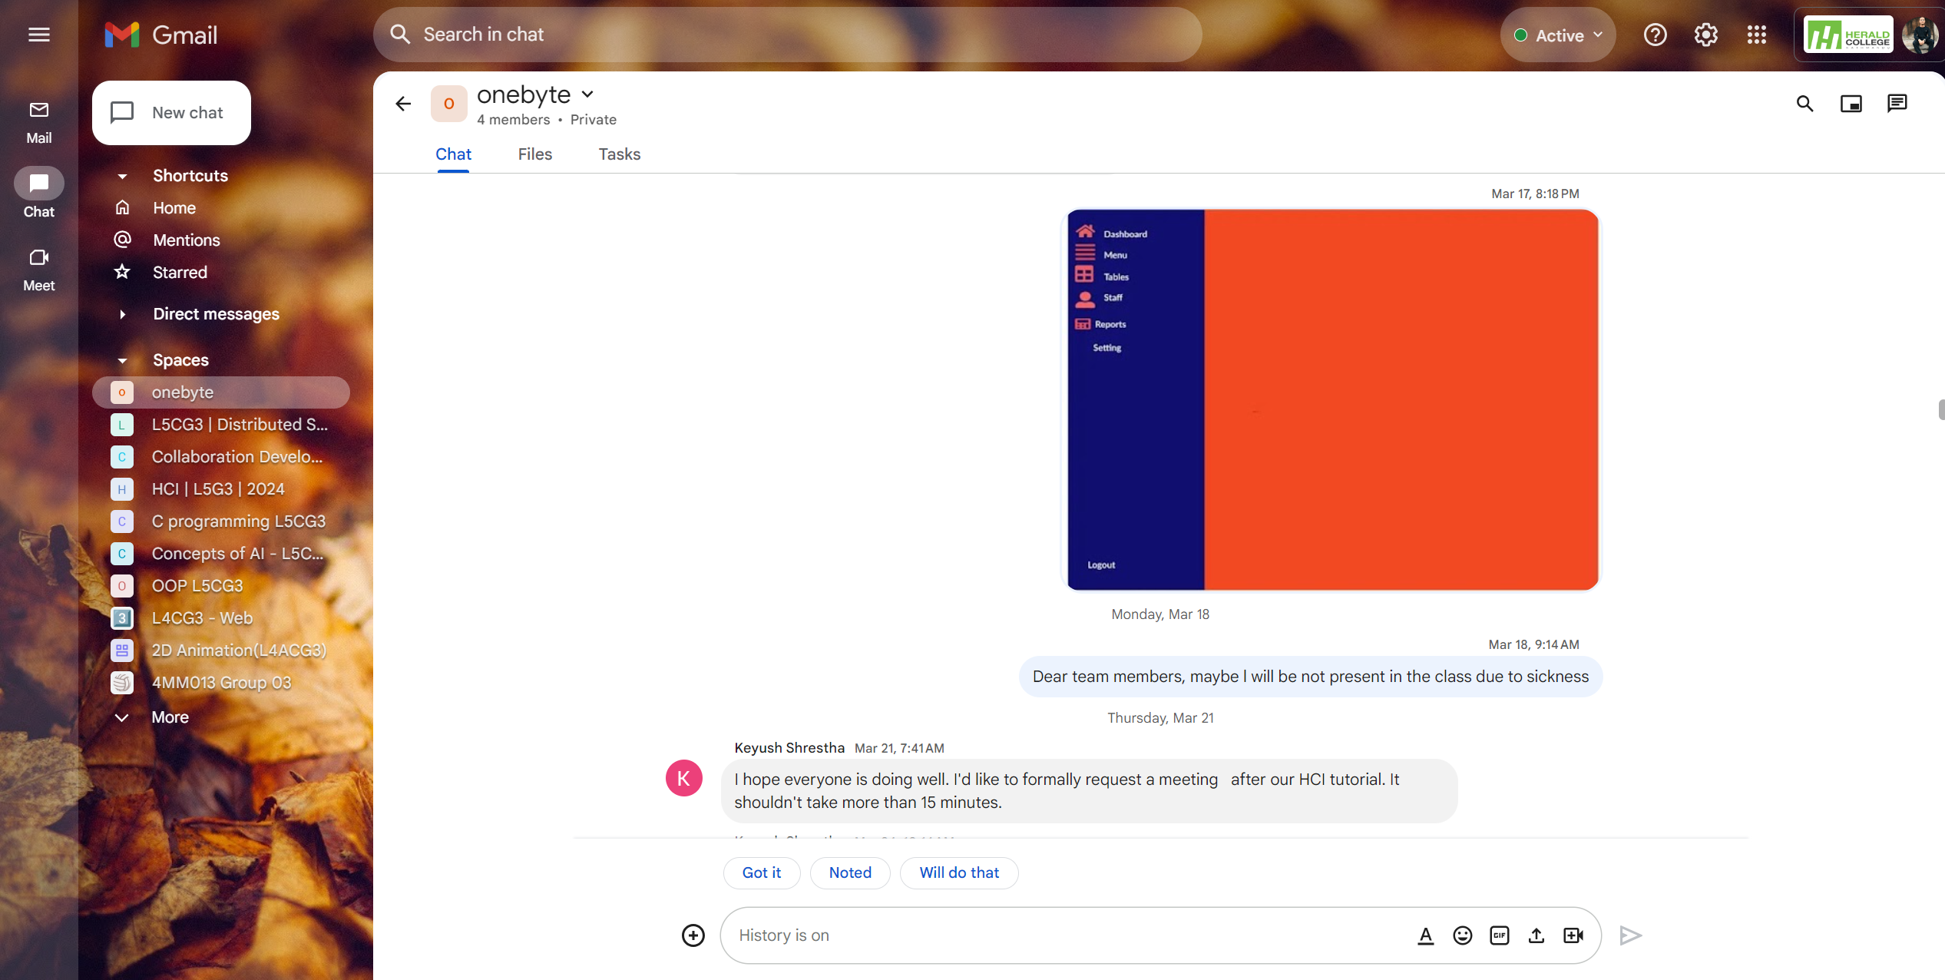

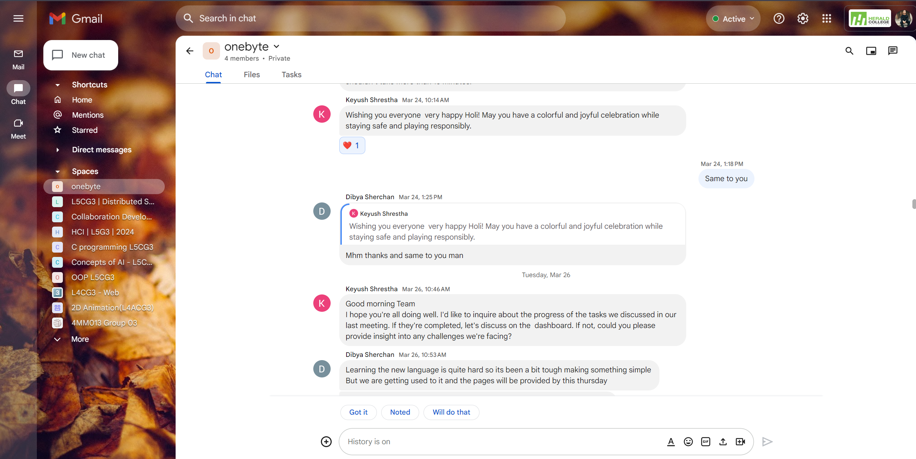

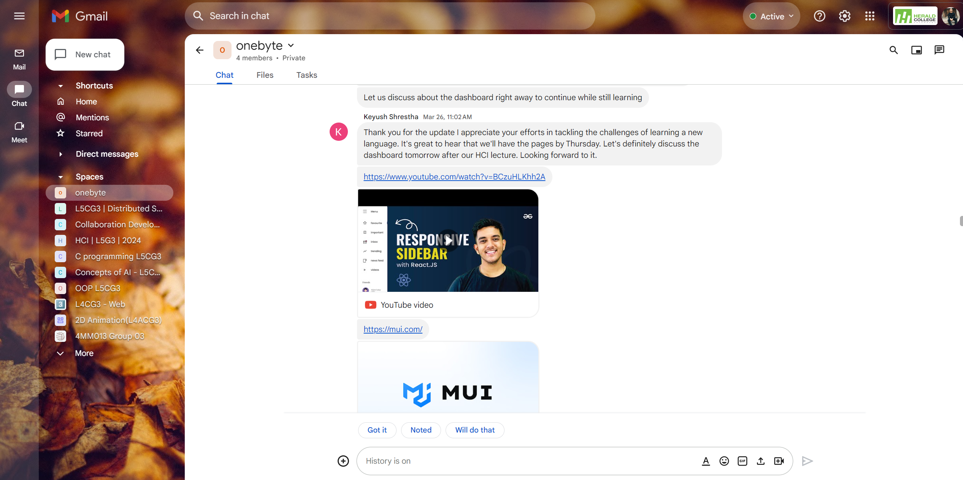

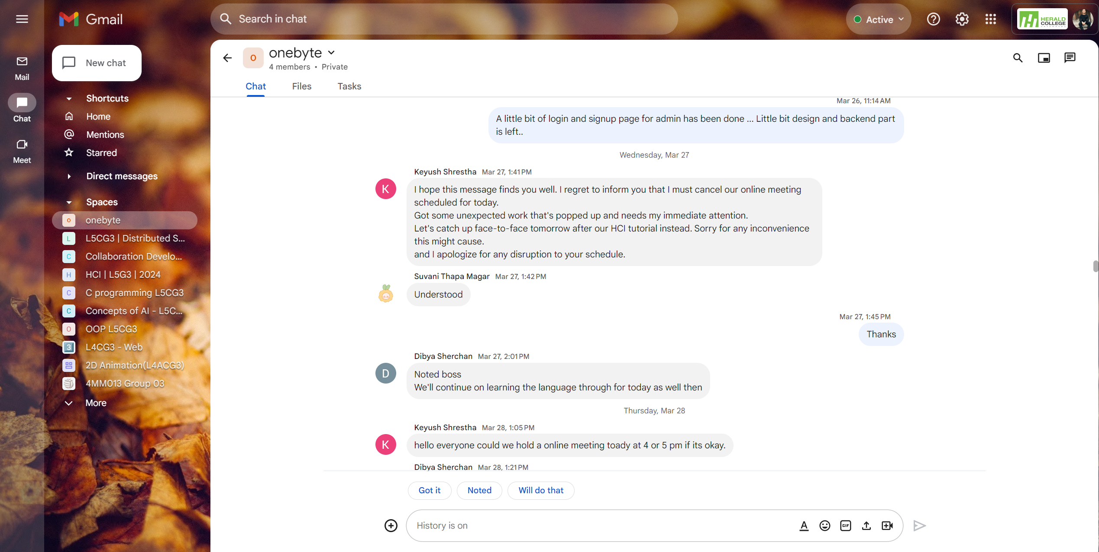

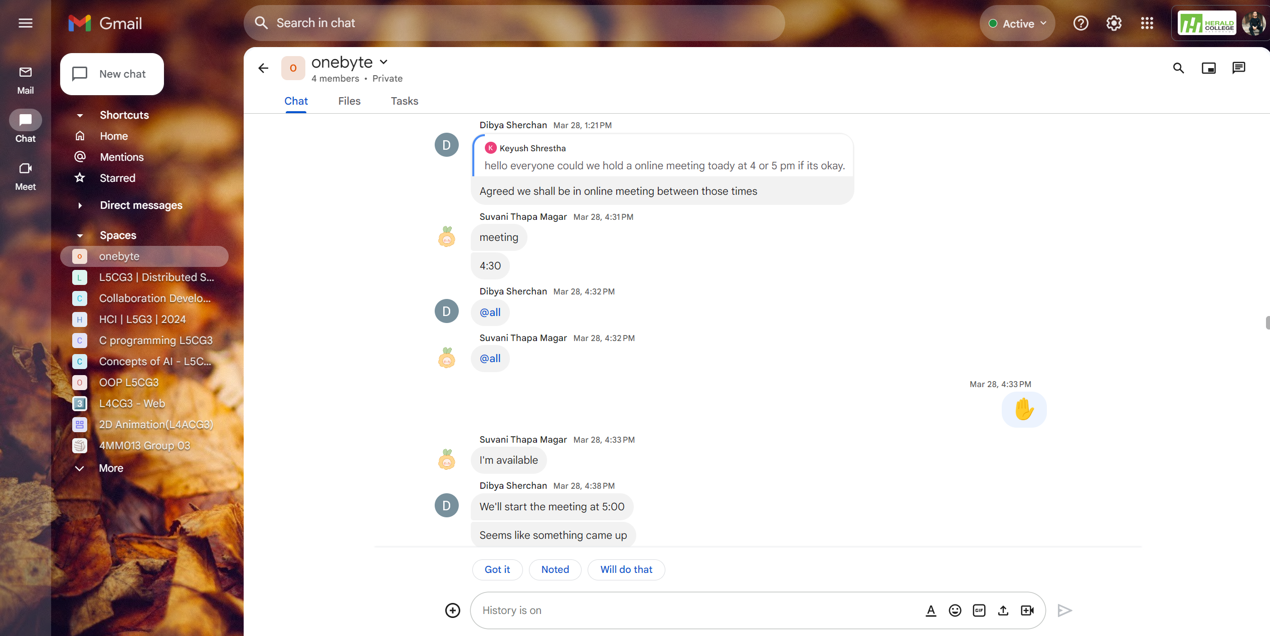

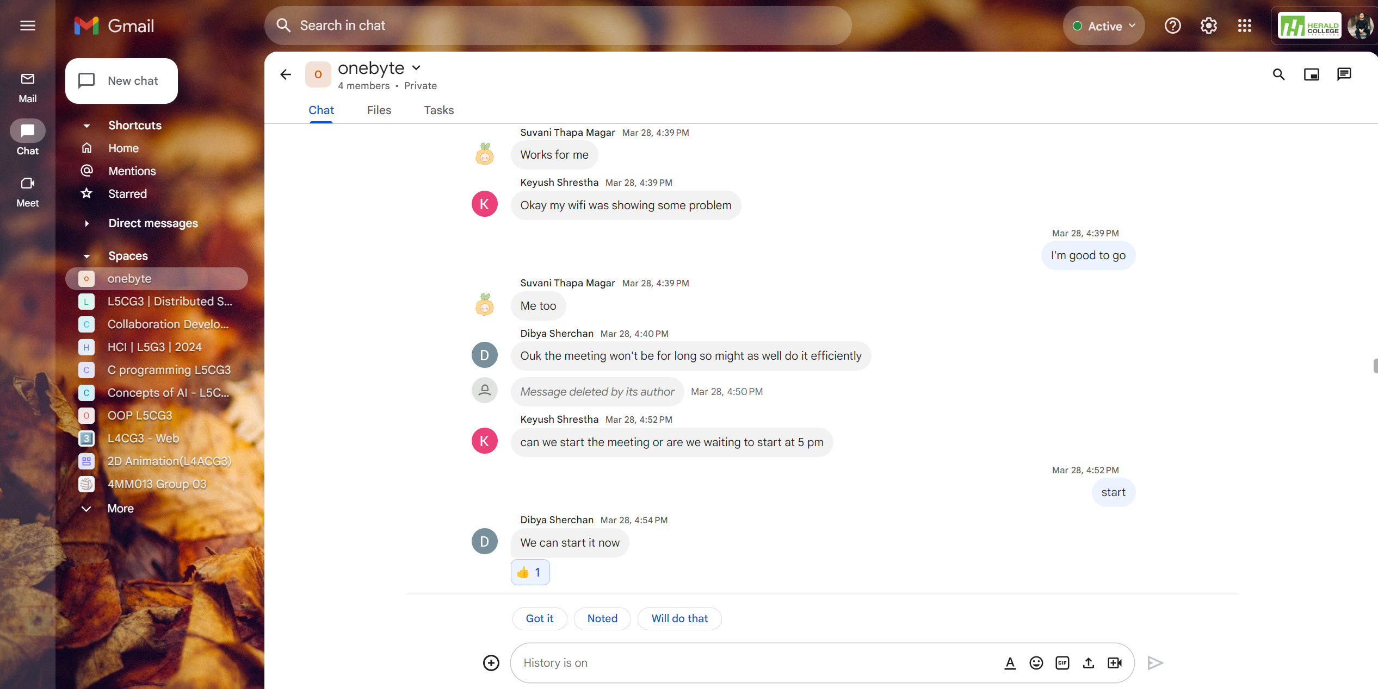

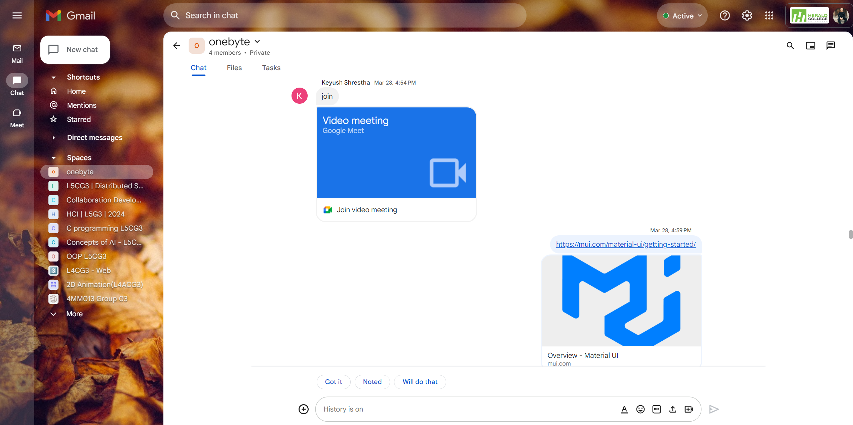

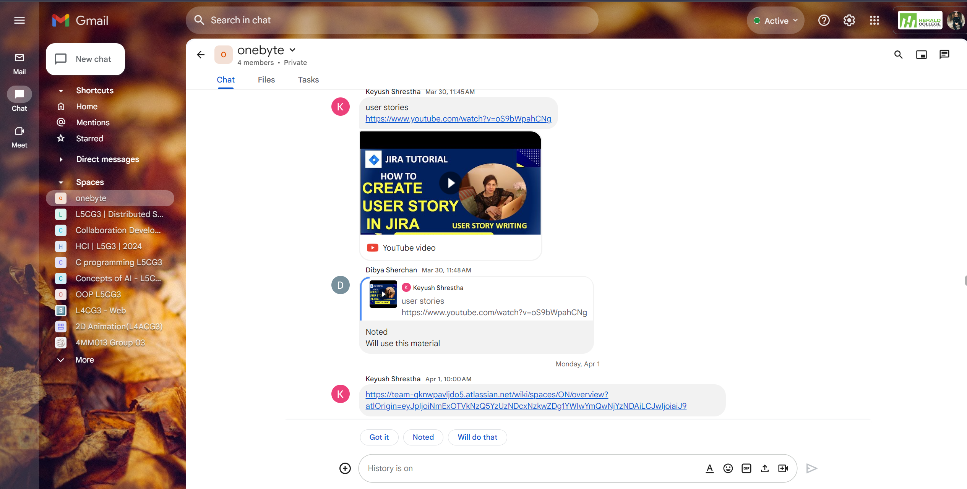

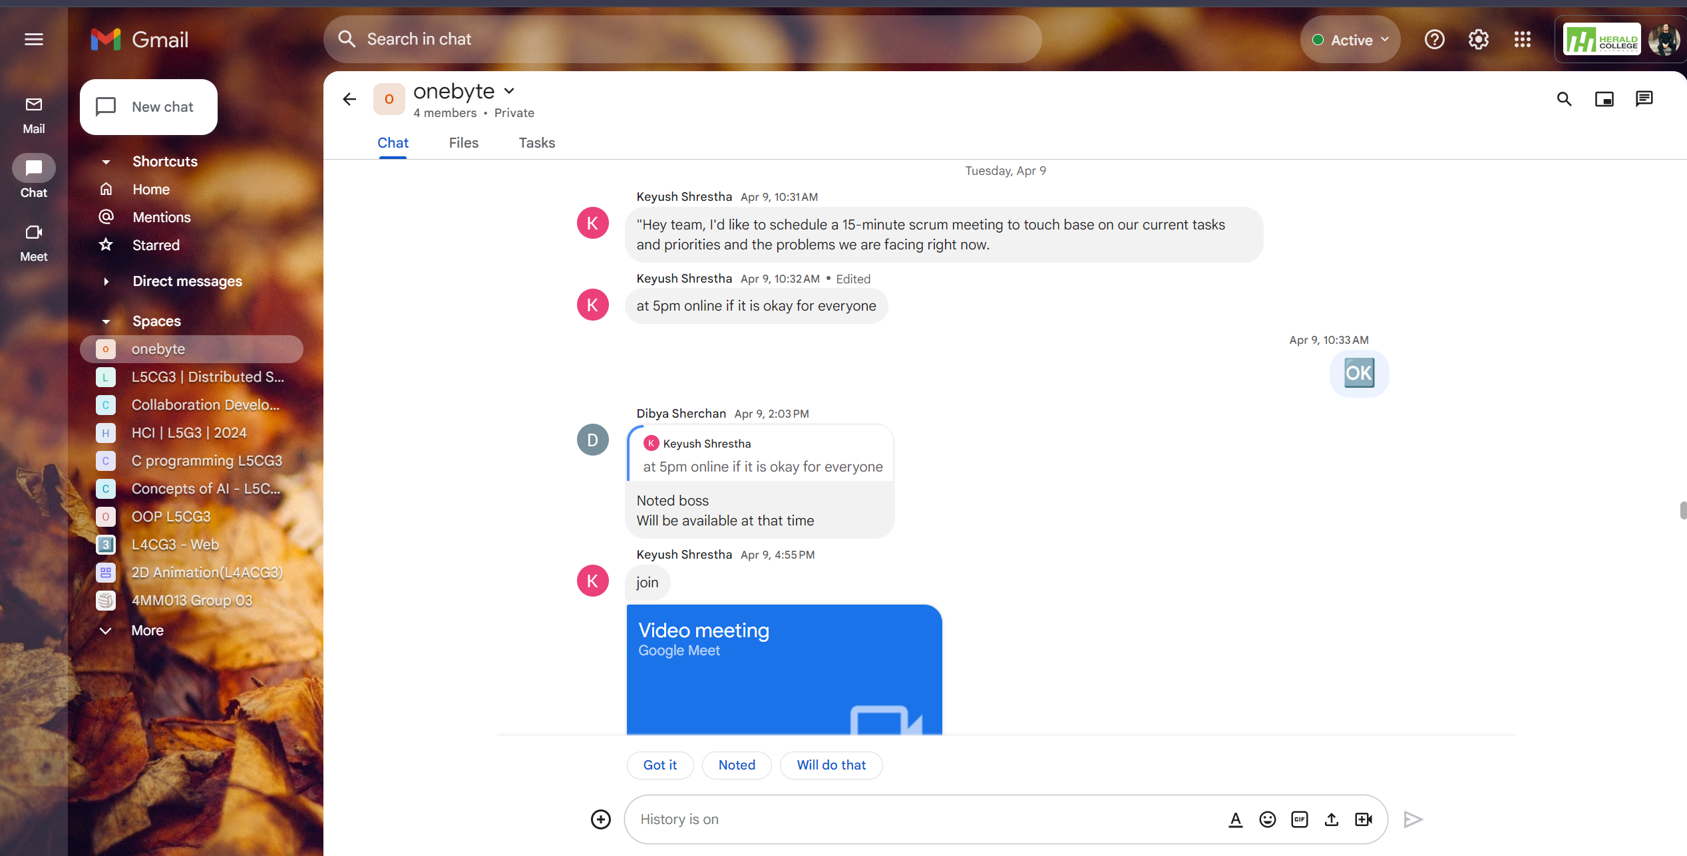

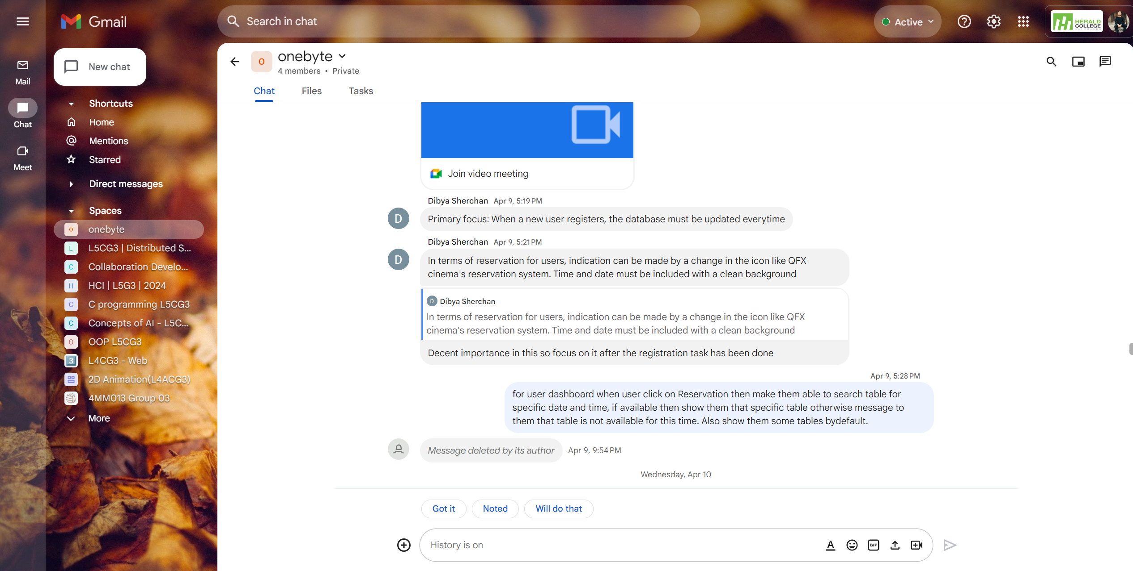

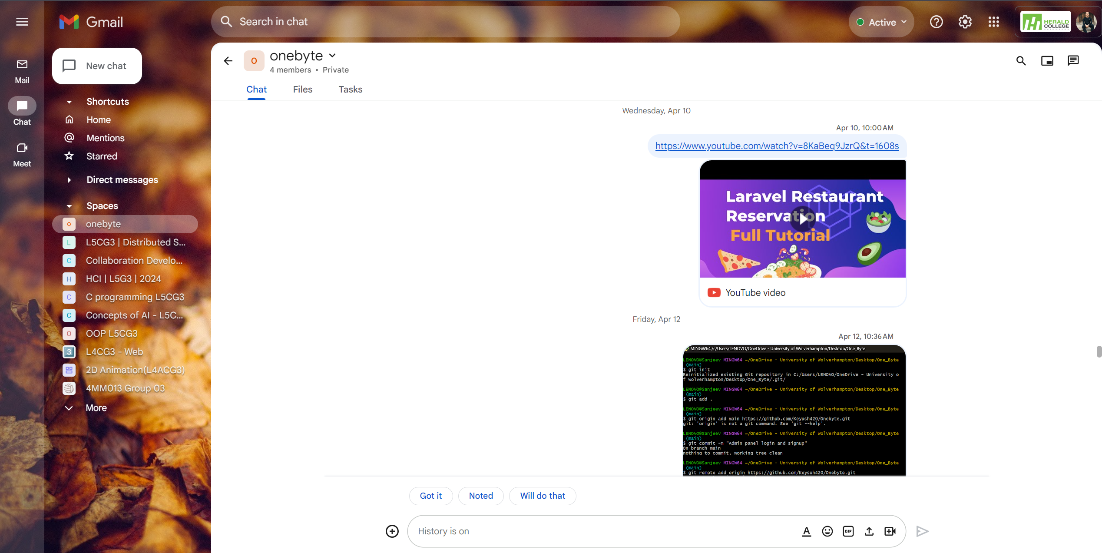

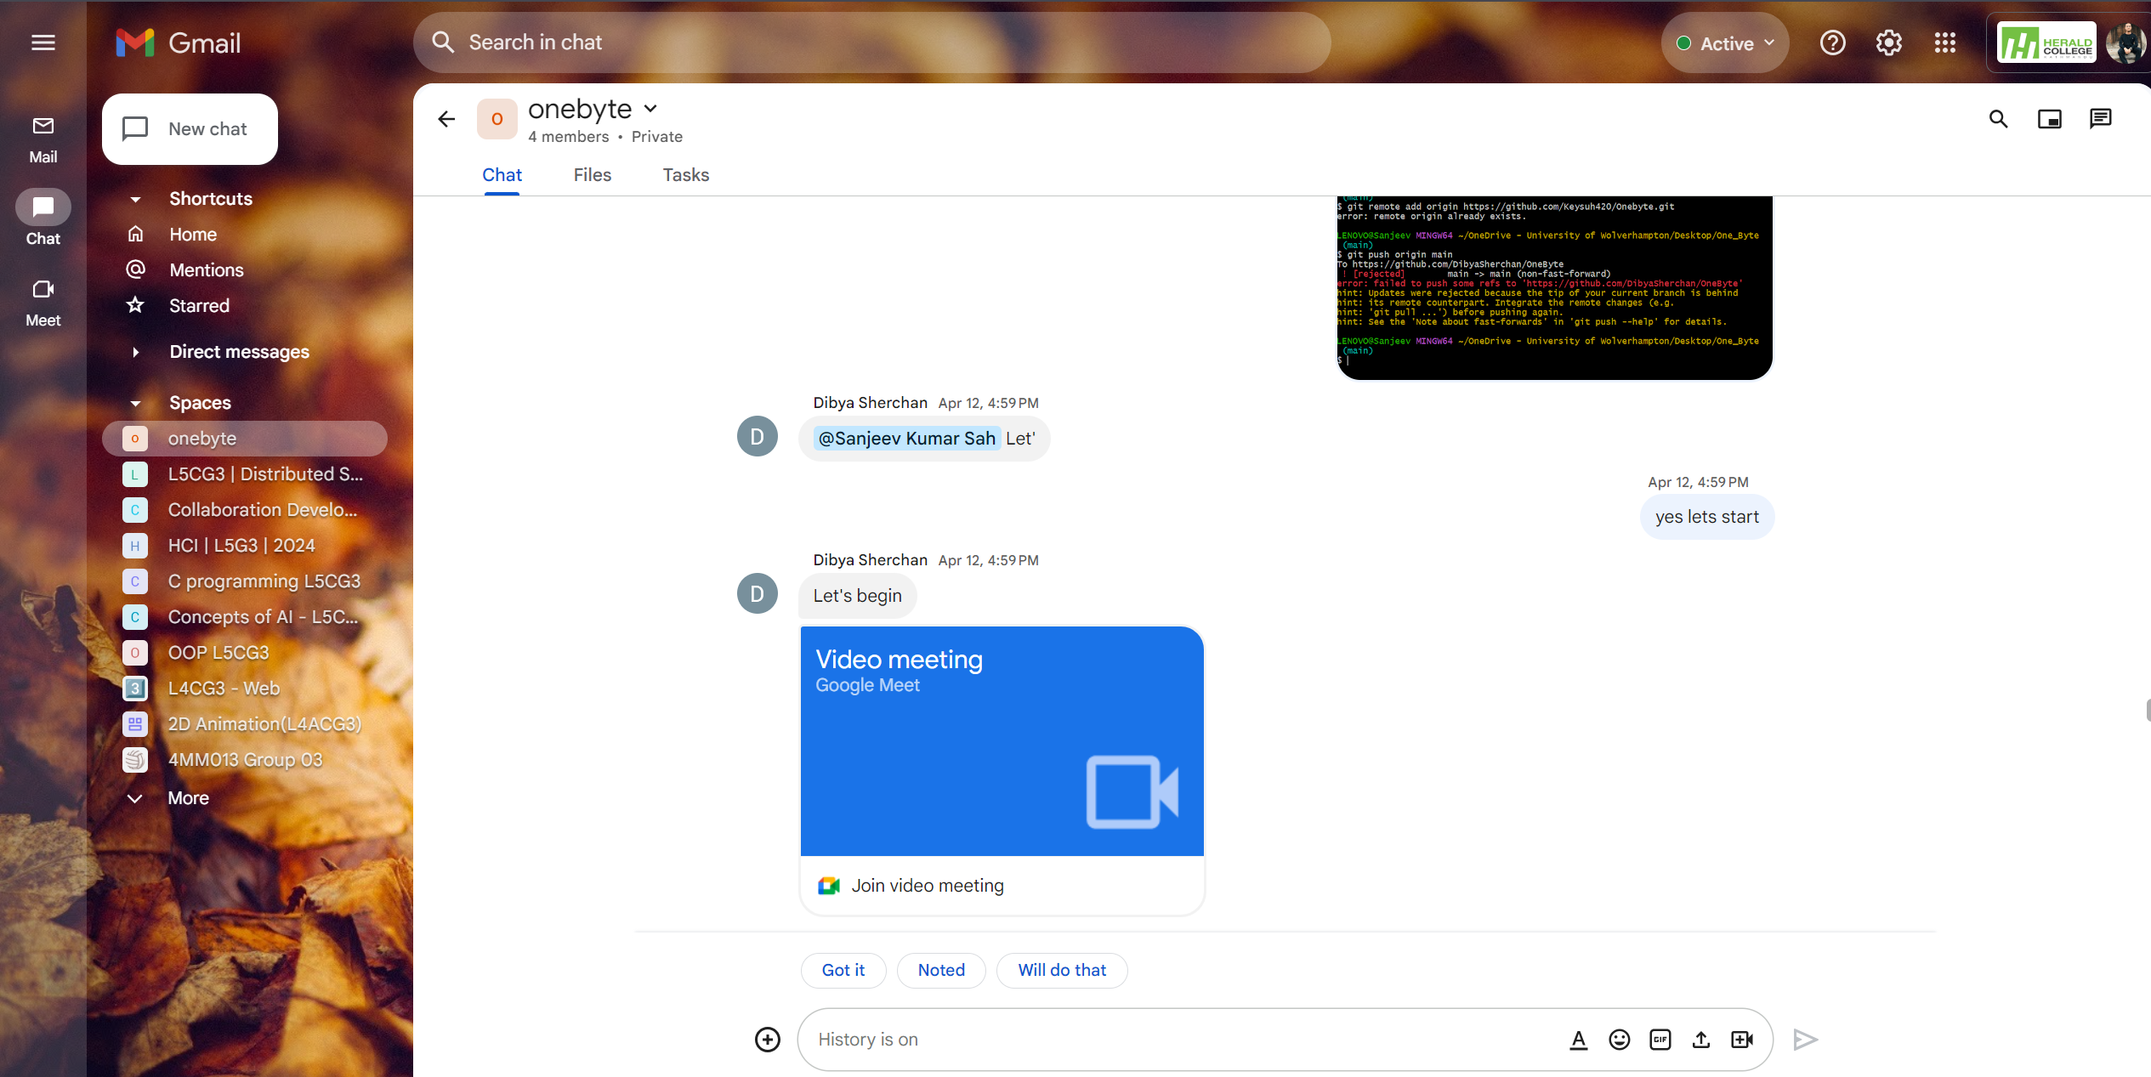

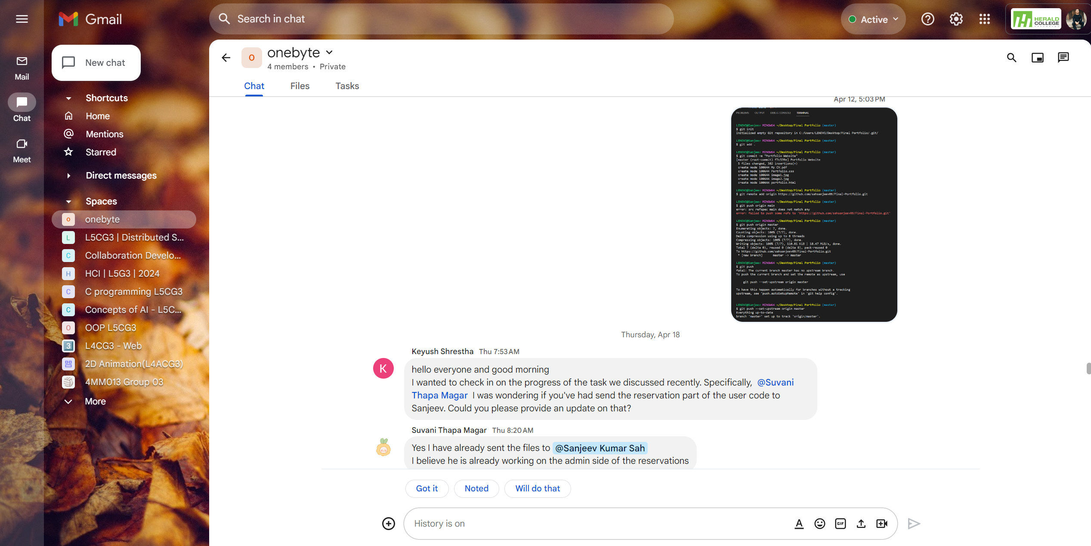

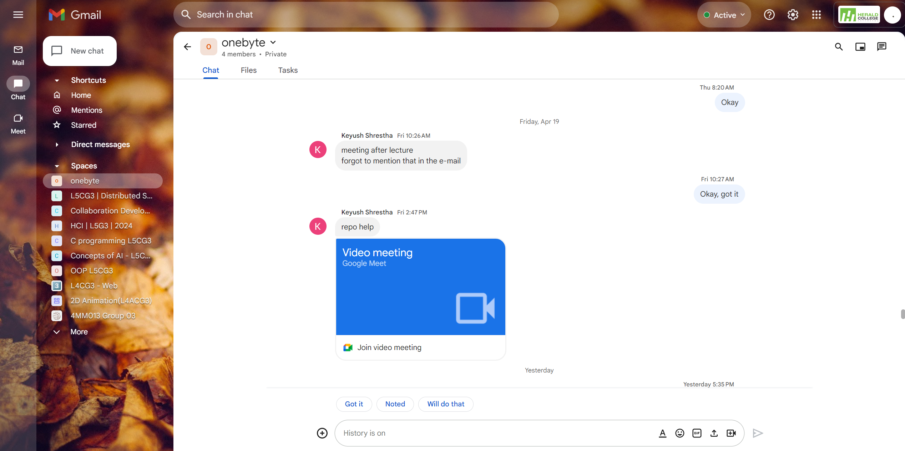

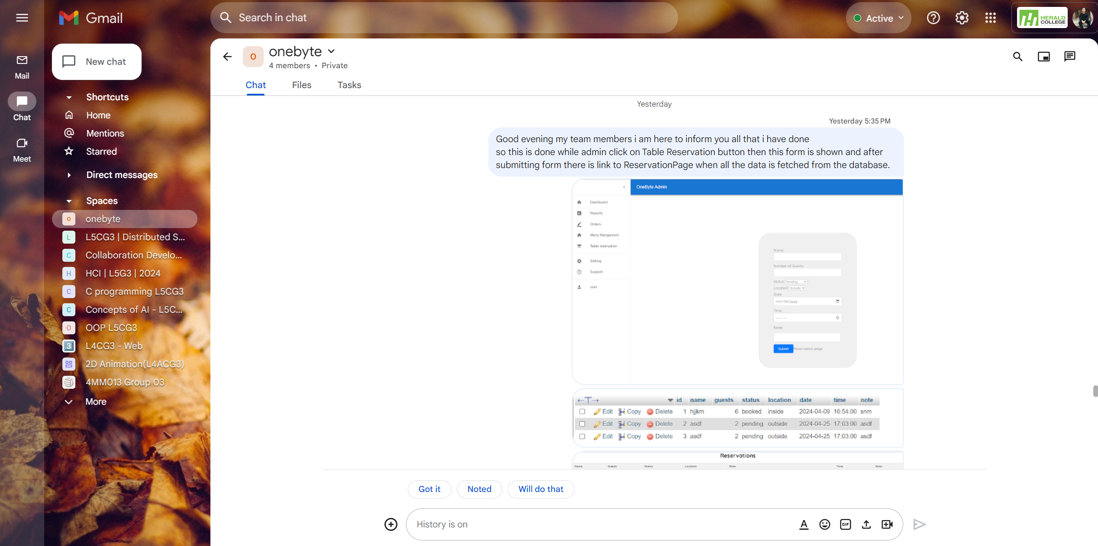

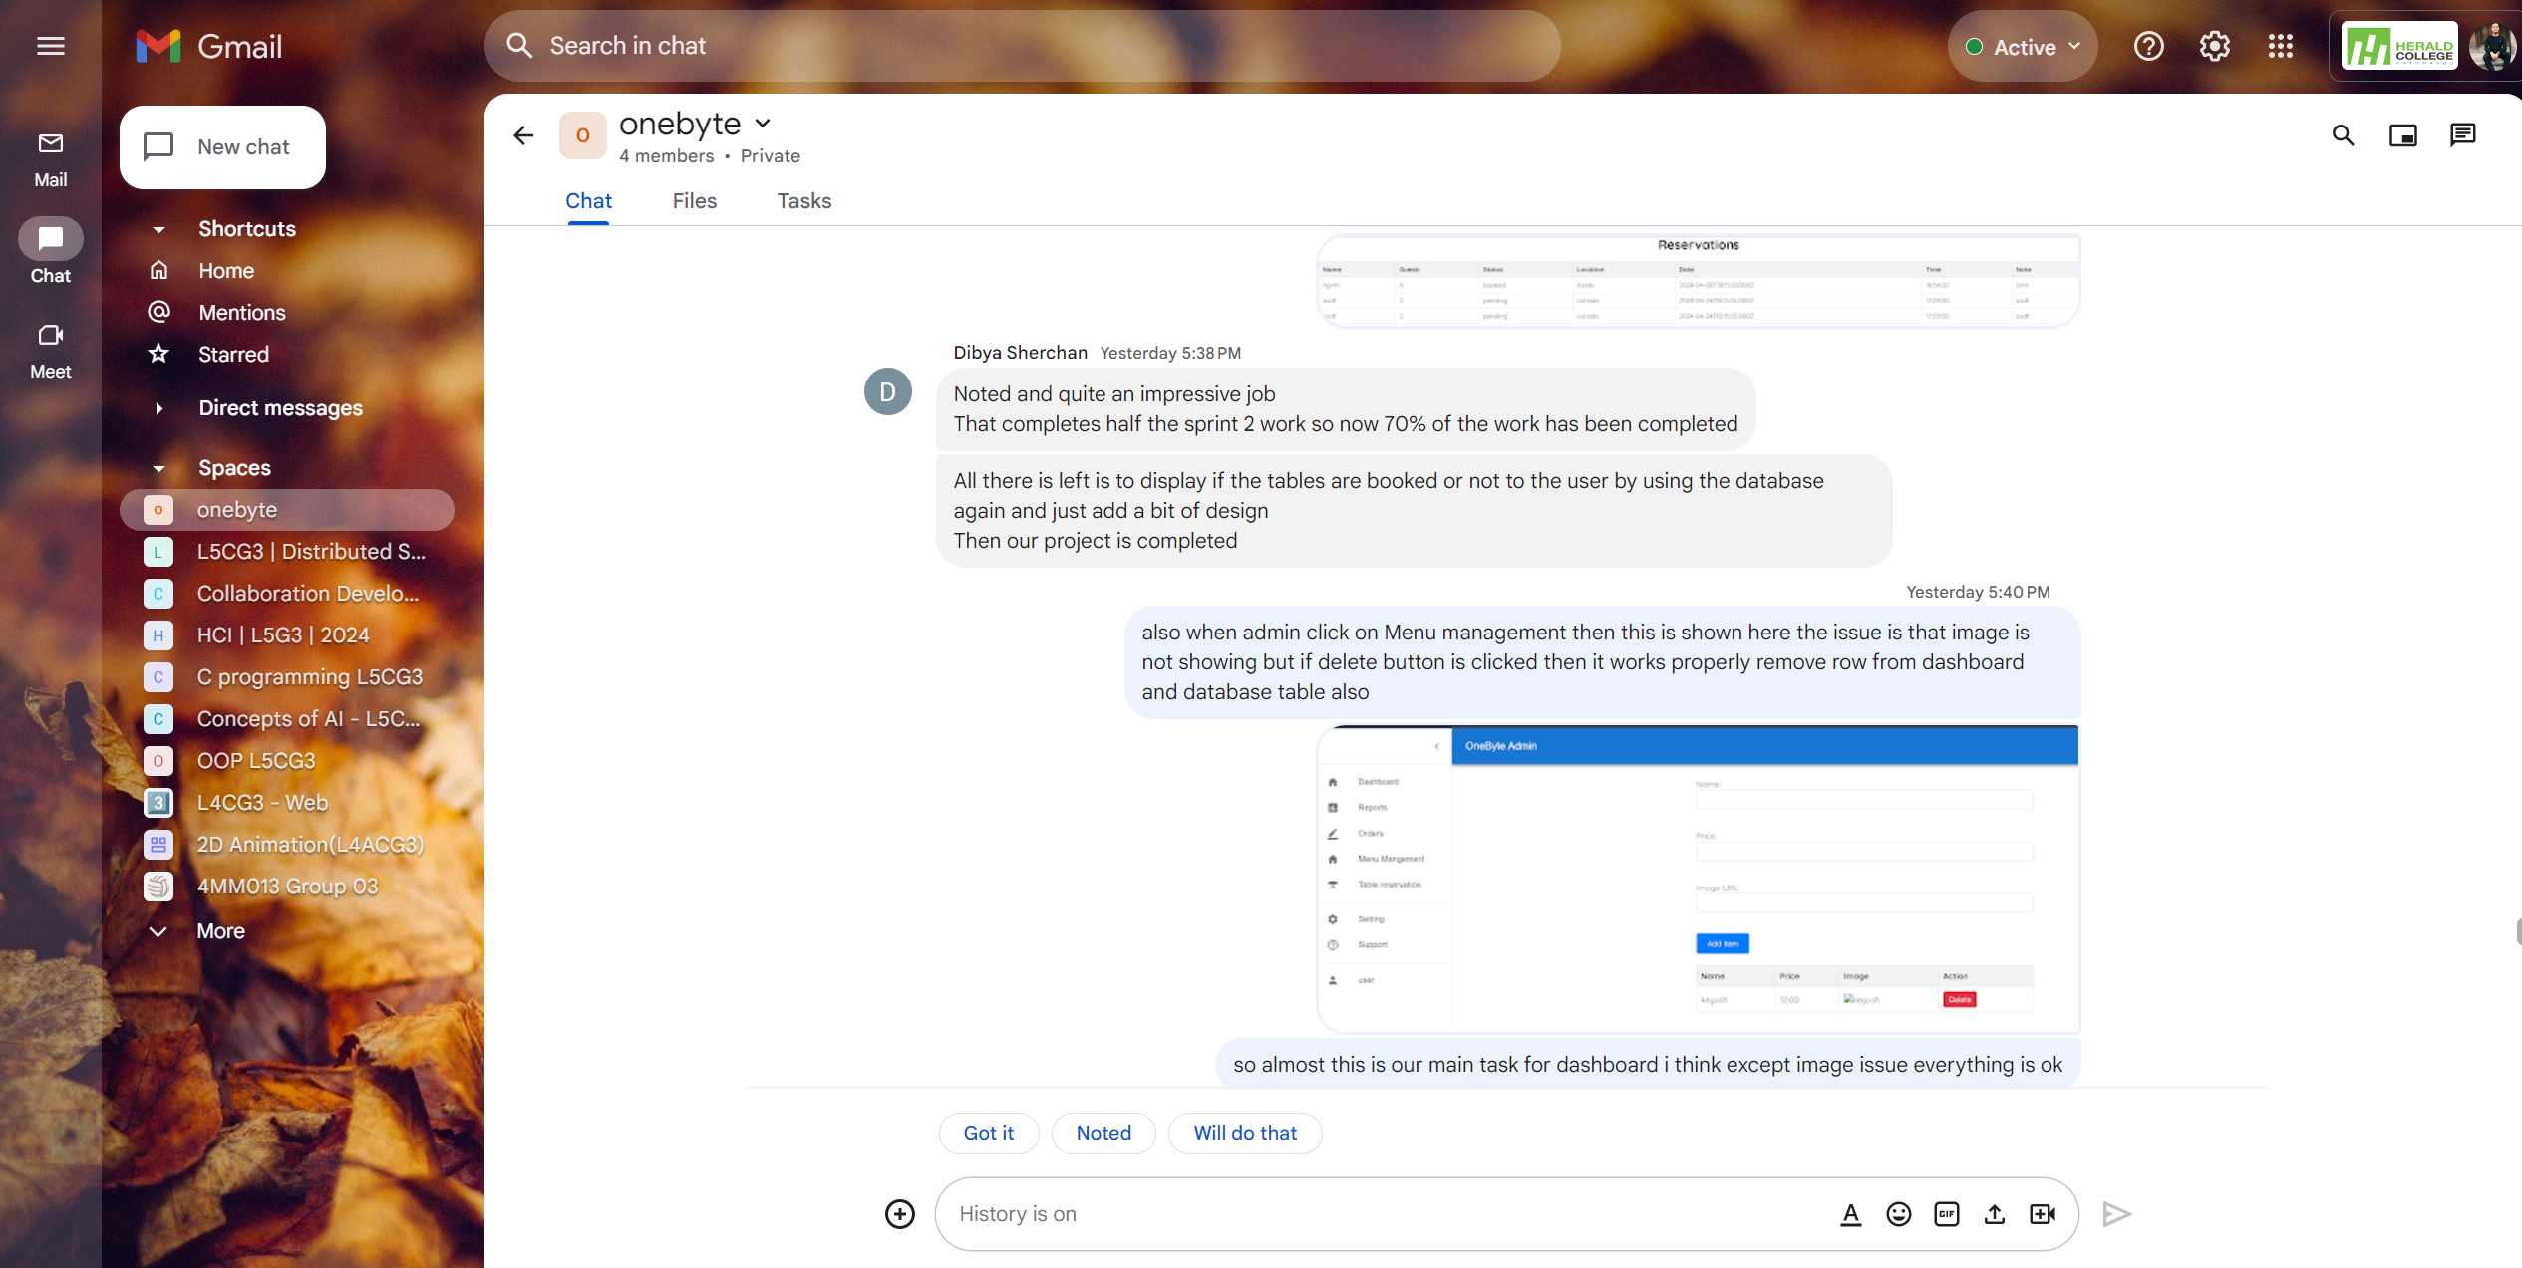

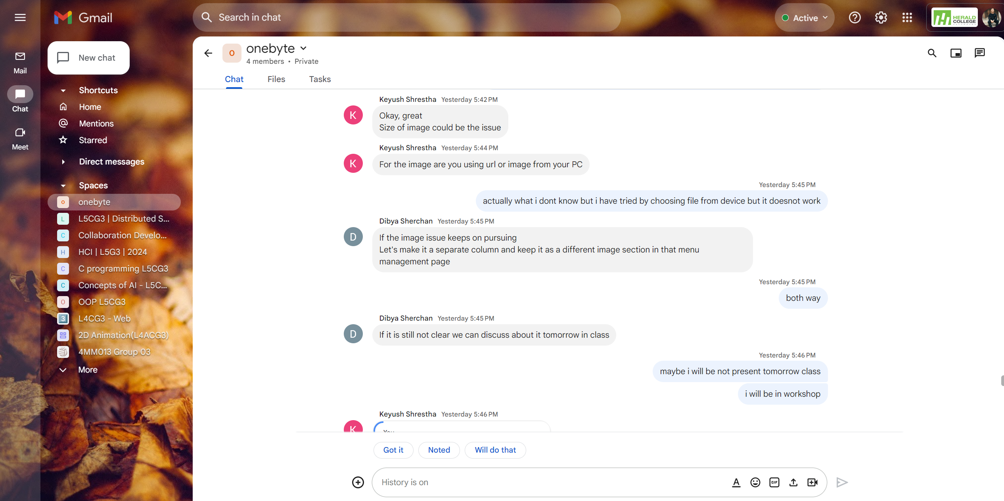

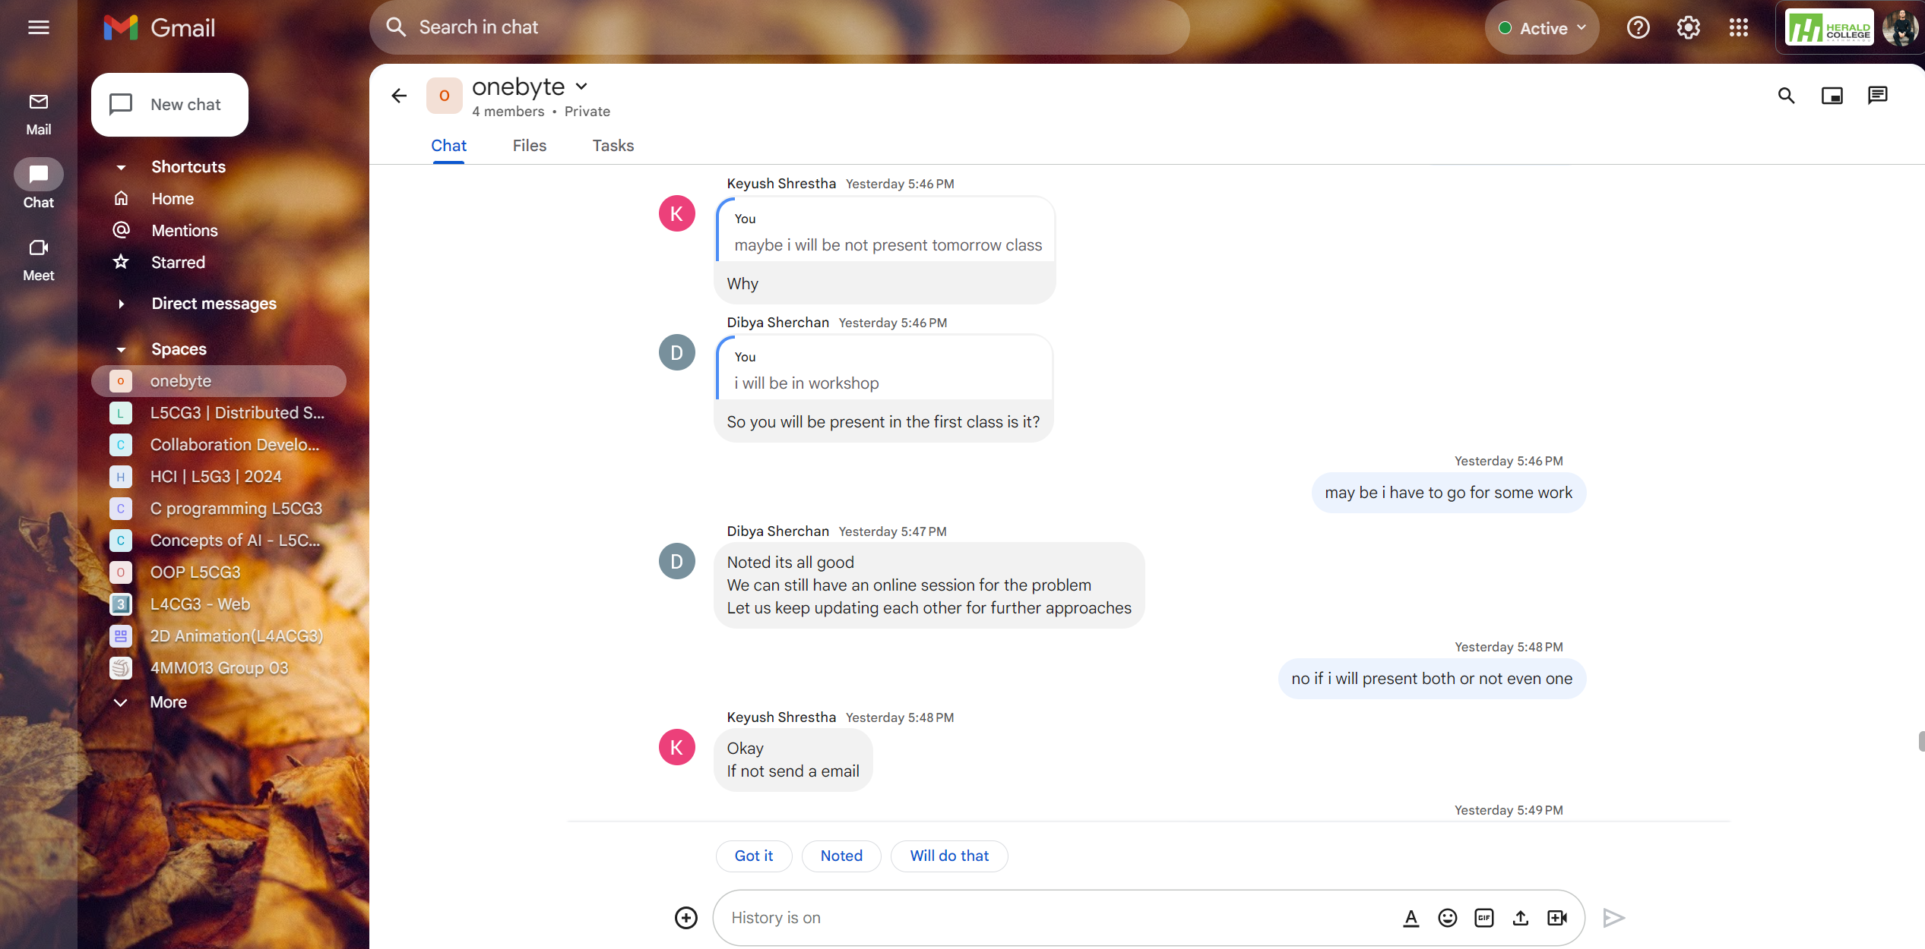

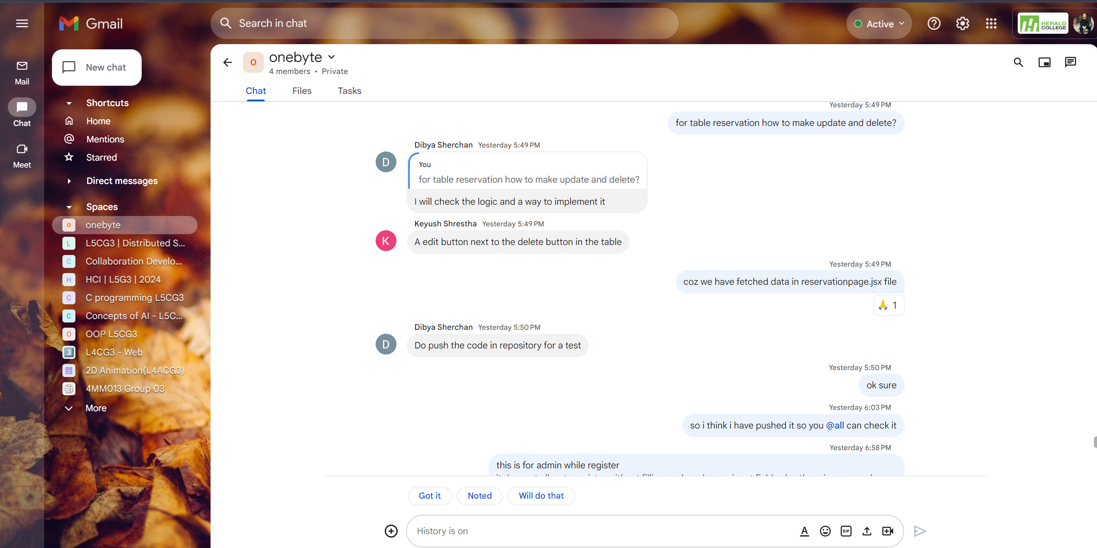

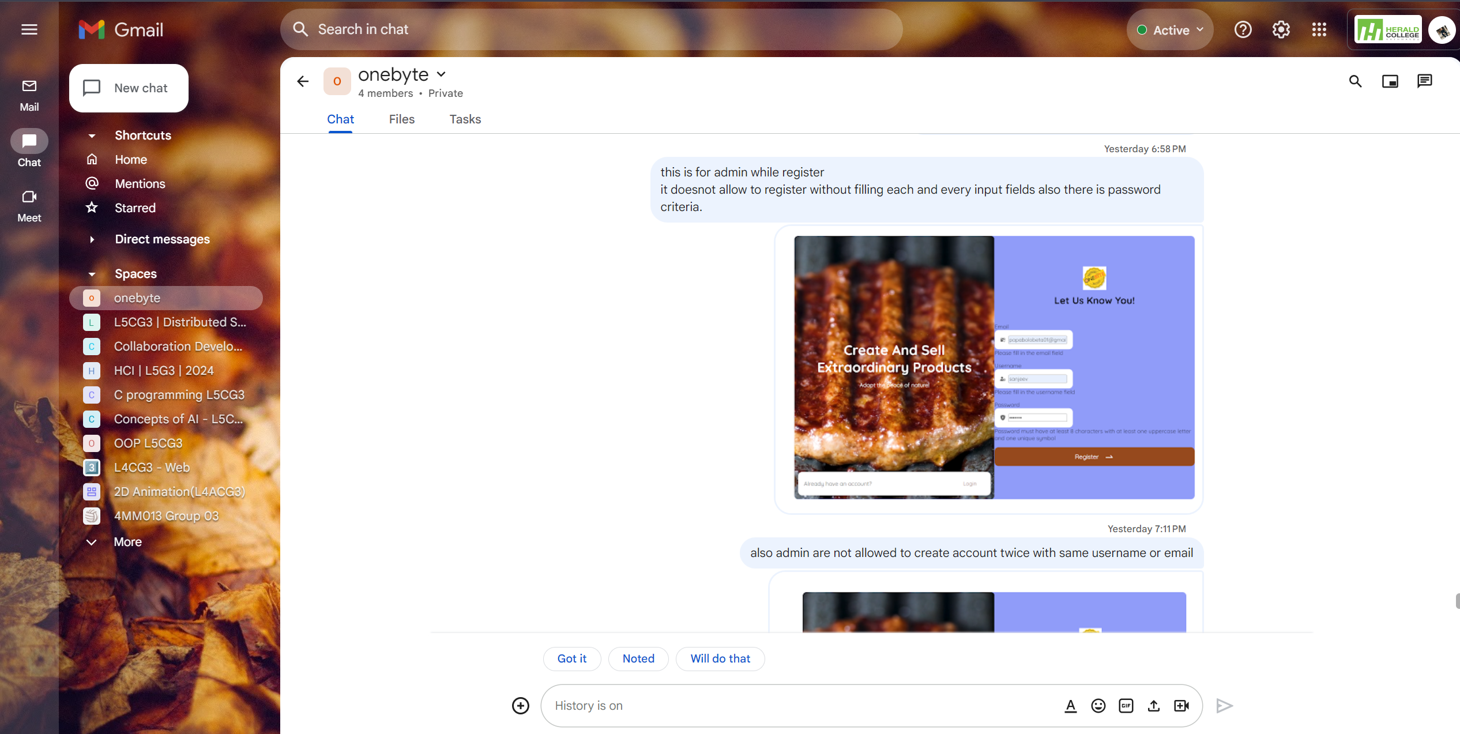

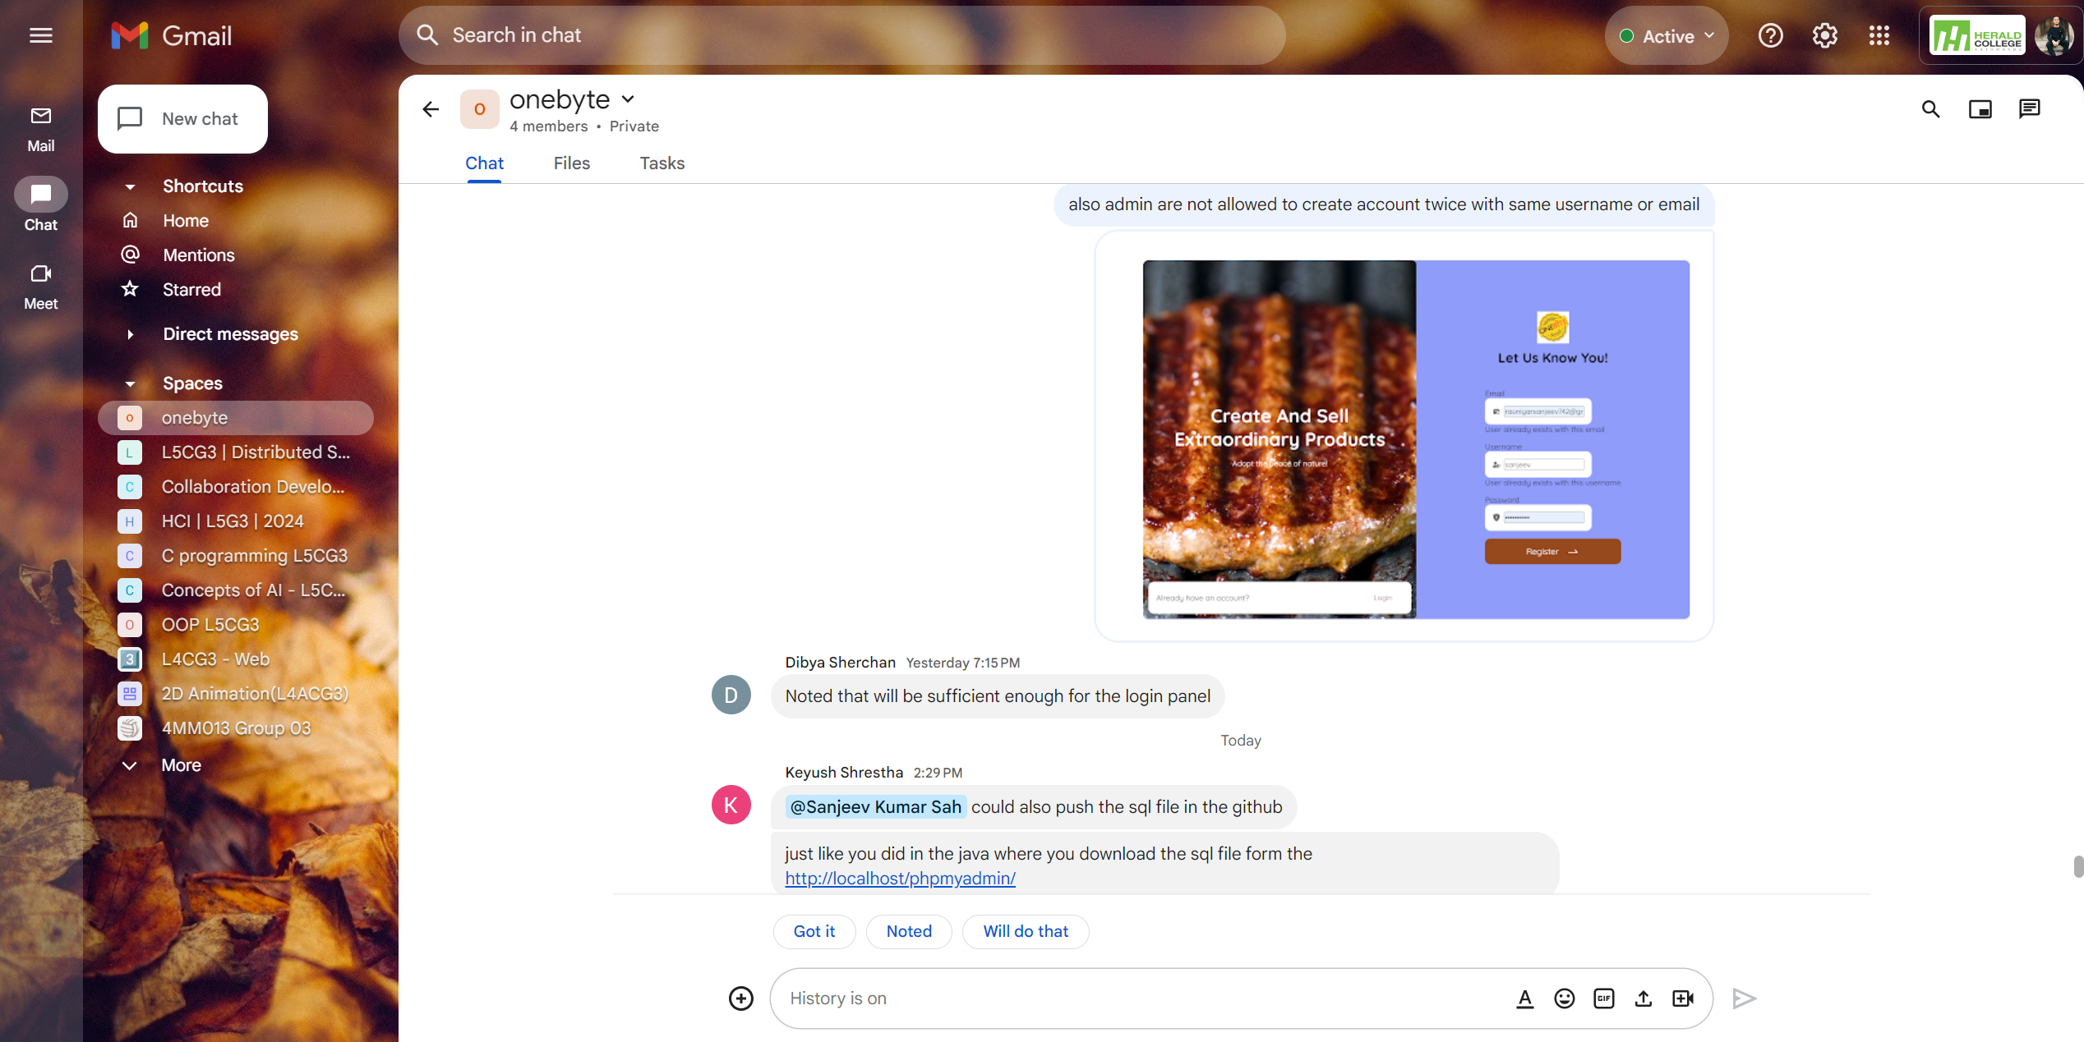

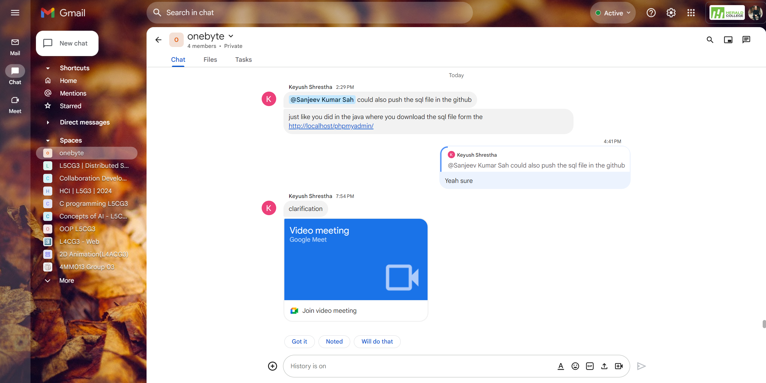

**Appendix D**

**Continuing Personal Development (CPD)**

**Online YouTube React Course**

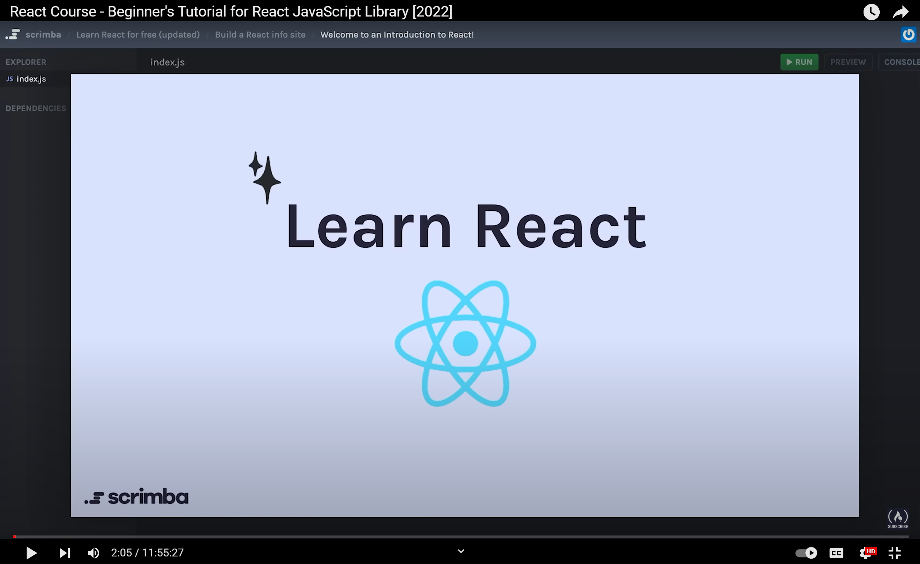

[freeCodeCamp.org](https://www.youtube.com/@freecodecamp)

freeCodeCamp.org

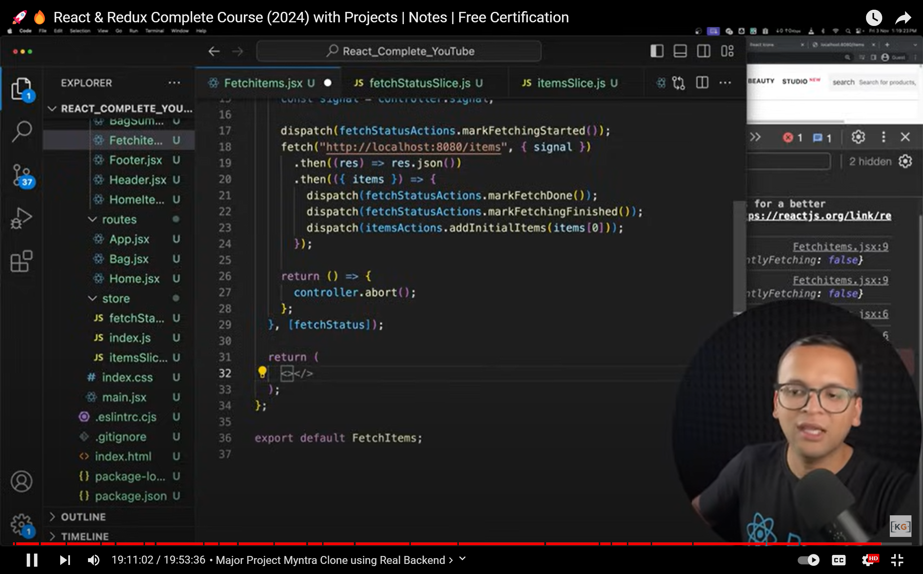

KG Coding by Prashant Sir

**W3Schools online React Course**

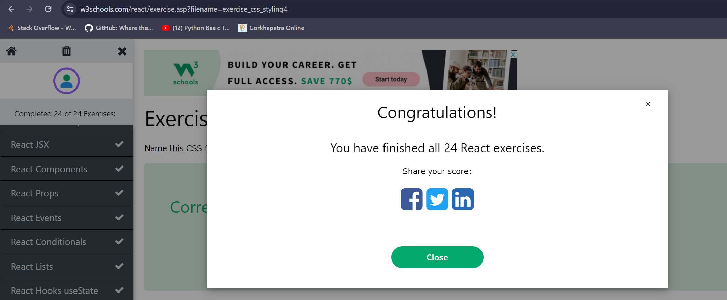

React Documentation

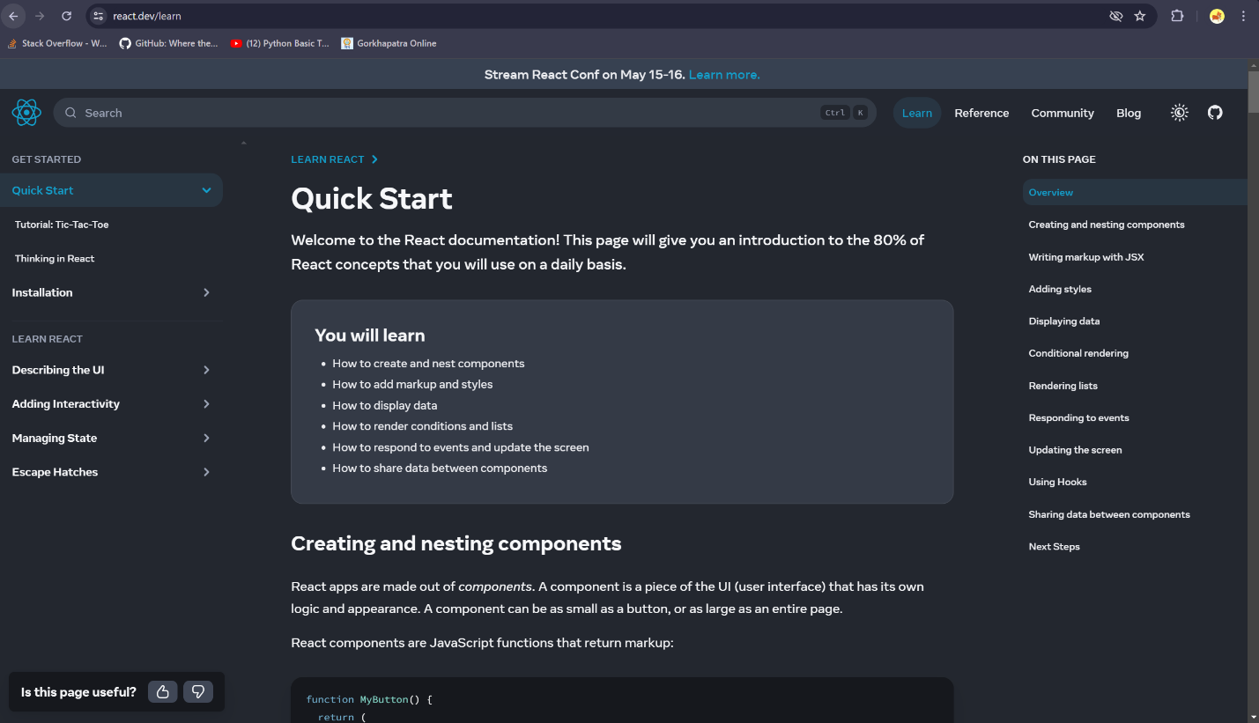

JavaScript is a scripting or open-source programming language and used for creating dynamic and interactive content on websites and used across various platforms. JavaScript is primarily known for its use in front-end web development, it can also be used for backend development.

In the development of my restaurant dine-in reservation system, JavaScript served as the cornerstone language for both frontend and backend functionalities.

React is a front-end JavaScript framework which is used for building user interfaces-based UI components. React can be used to create simple to complex web applications and it also enables developers to create reusable components. One of the main advantages of react is it is simple, the component-based approach, automatic rendering, and use of just plain JavaScript make React very simple to learn and build a web applications. While it is not typically used as a full-fledged backend framework like Node.js, it can still play a role in the backend development process, especially when combined with other technologies like Node.js and Express.js. Additionally, it can also be used to build desktop and mobile applications using frameworks like React Native. Overall, while it is not commonly used for backend development in the same way as Node.js, it can still have a role in certain backend tasks or in full-stack development scenarios. Node.js, a runtime environment for JavaScript, allows developers to run JavaScript code on the server-side, enabling full-stack development using a single language.

To learn more about React.js, various platforms were utilized, including YouTube, where two good channels, FreeCodeCamp and KG Coding by Prashant Sir, were employed. Videos for beginners were watched, focusing on the core concepts of React.js.

W3School was also utilized, mainly for basics knowledge gained, where React.js quizzes were taken, such as the React.js 24 exercises. Additionally, W3School was utilized to learn more about React.js. The official React.js documentation was found to be the most trustworthy, easy to navigate, and containing everything from small instructions.

Practical implementation of React.js knowledge involved tasks such as creating tables for database systems using React.js models and defining functions for HTML templates using views. Best practices for structuring HTML templates and organizing static files like images, CSS, and JavaScript were applied.

In conclusion, React.js harnesses high-level knowledge about JavaScript and web applications, and different platforms and courses were utilized to gain proficiency and readiness for project development. The acquired knowledge was implemented in practice, aiding personal development and enhancing skills as a React.js programmer.

**Appendix E**

Issue Tracking

Issue No.1

Solved issue No.1

Issue No.2

Solved issue No.2

Issue Tracking Report